Name:
Quiz 1, Attempt 1 (The solution is posted in the 2019 folder)
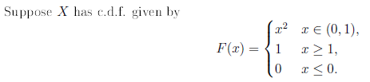
Find the variance of X.

