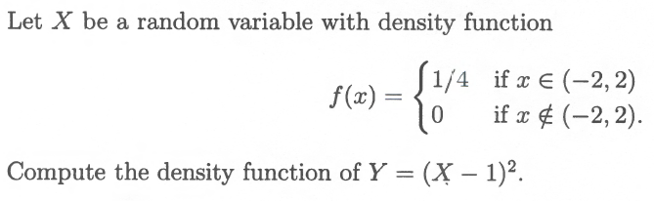

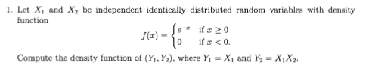

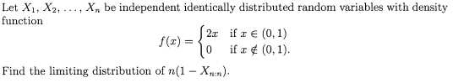

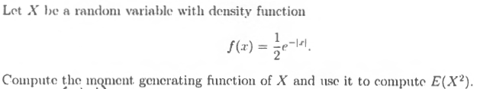

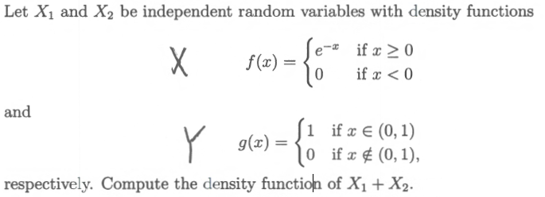

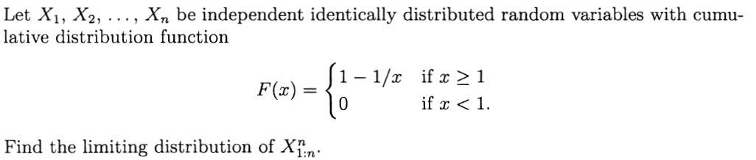

Estimate P(Σ X_{i} ≥ 27), where the sum represents a sum of 10 i.i.d. random variables with E(X) = 3 and var(X) = 5. Express your answer in terms of the cdf of a standard normal, Φ(⋅).

