Name:
Quiz 22, Attempt 1
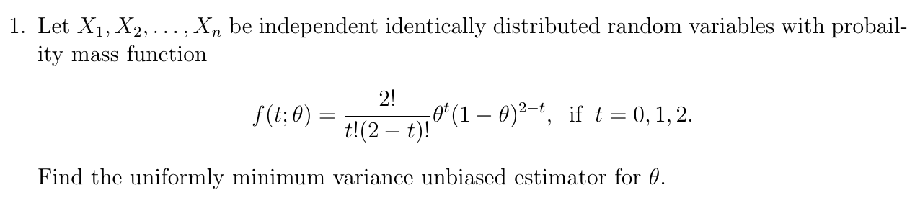

Quiz 20, Attempt 2
Based on a random sample from UNIF(-θ, θ), find a minimal sufficient statistic for θ.

