Name:
Quiz 9, Attempt 1
Quiz 7, Attempt 2
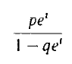
Note that the moment generating function for GEO(p) is

