Name:
Quiz 6, Attempt 1
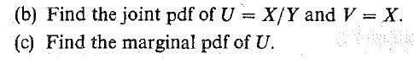

Quiz 4, Attempt 2
Suppose X and Y are uniformly distributed on the interval from 3 to 4. Assuming X and Y are independent, find the density function of their sum.

