Name:
Quiz 5, Attempt 1
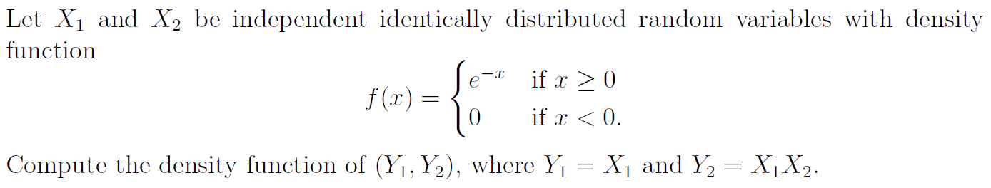

Quiz 3, Attempt 2
Suppose X has mass function given by f(x) = p(1-p)^{x}1{x = 0, 1, 2, …}. Find the mass function of Y = X².

