Name:
Quiz 3, Attempt 1
Suppose X has mass function given by f(x) = p(1-p)^{x}1{x = 0, 1, 2, …}. Find the mass function of Y = X+1. For practice (but not graded), you may also choose to consider how you would find the cdf of Y.

Quiz 1, Attempt 2
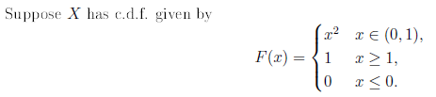
Find the expected value of X.

