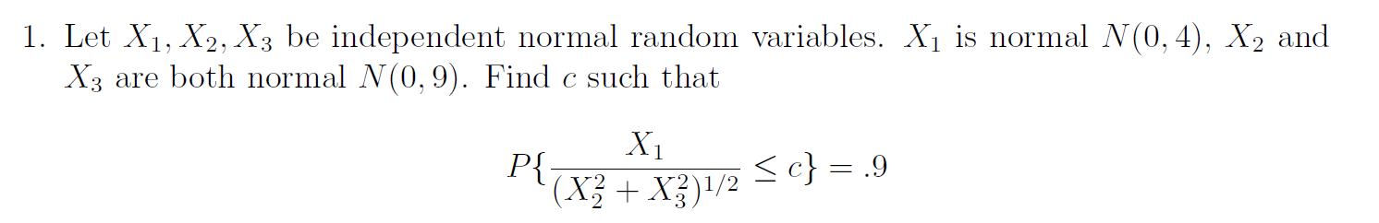

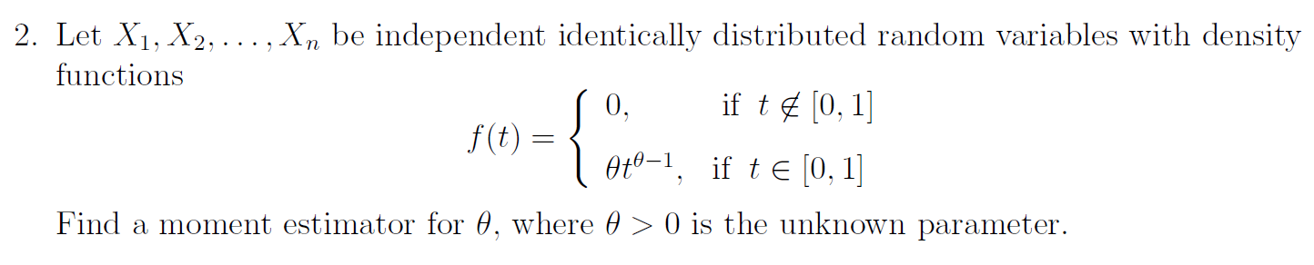

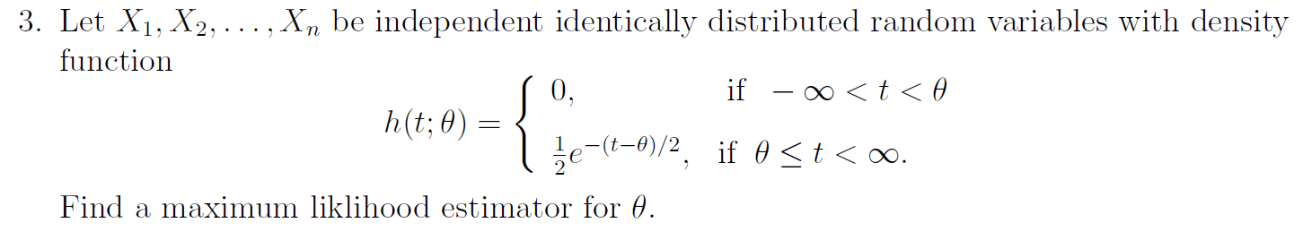

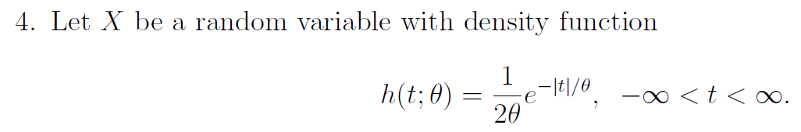
Find the CRLB for θ².

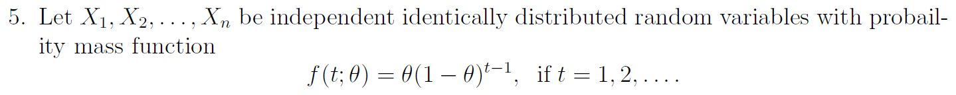
Find a sufficient statistic for 1/θ and then find a function thereof, which is unbiased for 1/θ.

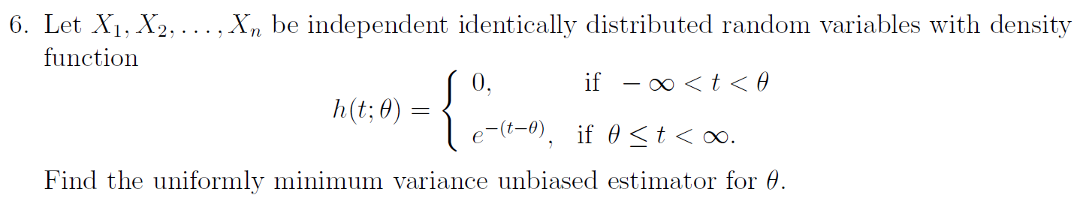
Explain how you know it is a UMVUE.

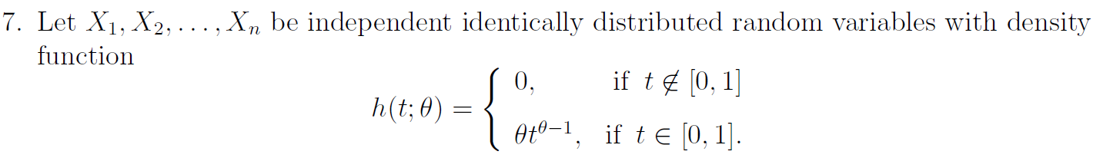
Find a sufficient statistic for θ. Is this sufficient for e^{θ}?

