Name:
Quiz 17, Attempt 2
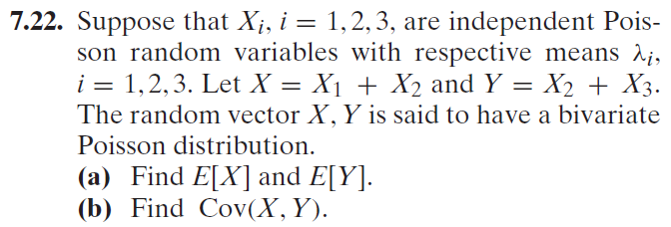

Quiz 18, Attempt 2
Suppose X, Y, and Z are independent. If X and Y are each POI(7), and if X, Y, and Z are independent, and if X+Y+Z is POI(100), what is the distribution of Z?

