Name:
Quiz 18, Attempt 1
Suppose X and Y are independent and have POI(7) distributions. What is the distribution of X+Y?

Quiz 16, Attempt 2
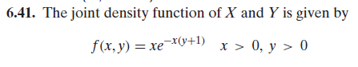
Find the expected value of X given that Y = 1.

