Name:
Quiz 17, Attempt 1
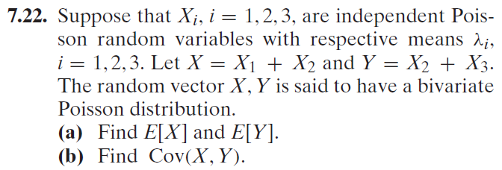

Quiz 15, Attempt 2
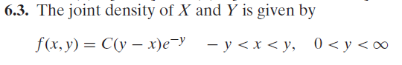
Find C and then find the marginal density function for Y.

