Name:
Quiz 16, Attempt 1
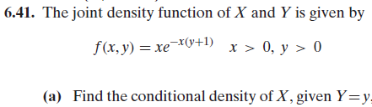

Quiz 14, Attempt 2
