Name:
Quiz 15, Attempt 1
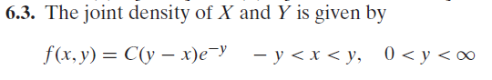
Find C and then find the marginal density function for X.

Quiz 13, Attempt 2
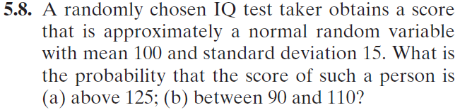
Express your answers in terms of, Φ(.), the cdf of a standard normal.

