Name:
Quiz 14, Attempt 1
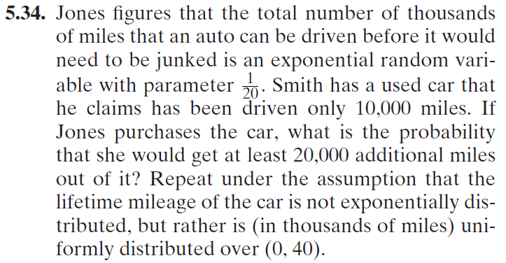

Quiz 12, Attempt 2
