Name:
Quiz 13, Attempt 1
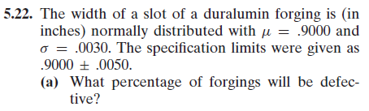
Express your answer in terms of, Φ(.), the cdf of a standard normal.

Quiz 11, Attempt 2

