Name:
Quiz 12, Attempt 1

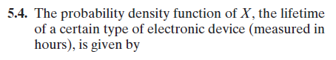
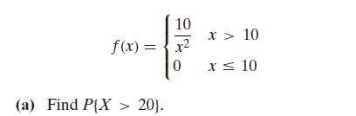

Quiz 10, Attempt 2
