Name:
Quiz 11, Attempt 1
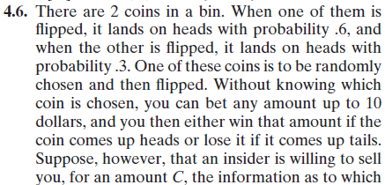
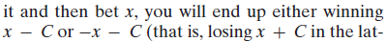
Assume that you buy the insider information and the coin that was flipped lands on heads with probability 0.6. Assume the information costs C=$1 and that you decide to bet $10. Find the expected value and variance of your winnings.

Quiz 9, Attempt 2
