Name:
Quiz 10, Attempt 1
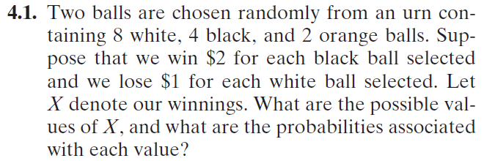

Quiz 8, Attempt 2
