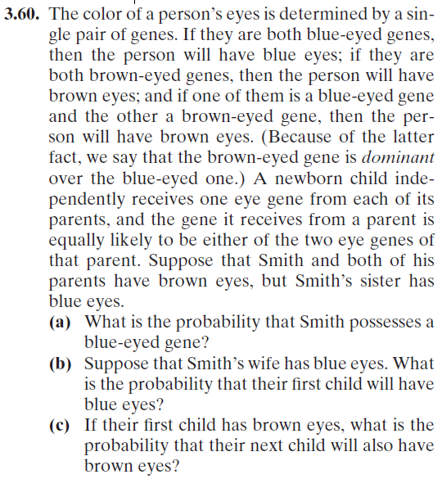
Name:
Quiz 9, Attempt 1

Quiz 7, Attempt 2
