Name:
Quiz 8, Attempt 1
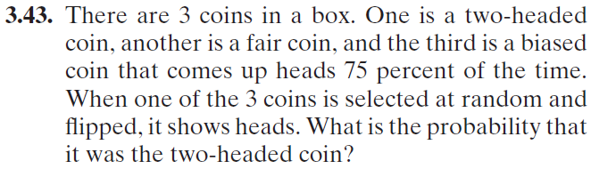
Quiz 6, Attempt 2
