Name:
Quiz 7, Attempt 1
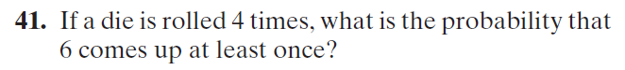

Quiz 5, Attempt 2
