Name:
Quiz 6, Attempt 1
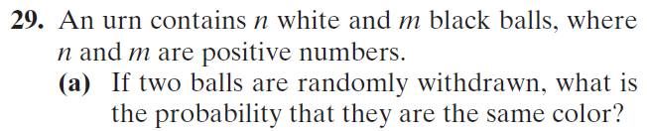

Quiz 4, Attempt 2
Consider a grid like the one below, except larger. Assume that the grid is 100 units wide and 20 units high. Suppose that, starting at the point labeled A, you can go one step up or one step to the right at each move. This procedure is continued until the point labeled B is reached. A is located at (0, 0) and B is located at (100, 20). How many different paths from A to B are possible, if you must go through the point (10, 10) but cannot go through (5, 5)? Think of a robot, starting at Point A, that must pick up a load at (10, 10) and deliver it to point B without setting off the landmine at (5, 5).
