Name:
Quiz 4, Attempt 1
Consider a grid like the one below, except larger. Assume that the grid is 100 units wide and 20 units high. Suppose that, starting at the point labeled A, you can go one step up or one step to the right at each move. This procedure is continued until the point labeled B is reached. A is located at (0, 0) and B is located at (100, 20). How many different paths from A to B are possible, if you must go through the points (5, 5) and (10, 10)? Think of a robot, starting at Point A, that must pick up a load at the two internal destinations and deliver them to point B.
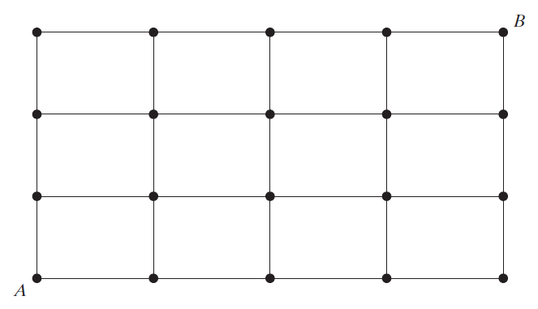

Quiz 2, Attempt 2
1.7c In how many ways can 3 boys and 3 girls sit in a row if the boys must sit together?

