Name:
Quiz 3, Attempt 1
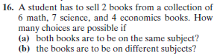

Quiz 1, Attempt 2
At Papa Murphy’s there is a special for a large 2-topping pizza for $6.99. My daughter, Maddie, wants meat on it, and my son Cameron wants a vegetable on it. Claire, a Papa Murphy’s employee, gets mad if you as for one half to be made differently than the other, so, in order to keep everyone happy, I’ll have to get a pizza that has a meat and a vegetable all over it. If there are 10 different vegetables to choose from, 5 different meats, and 2 different types of crust, how many different combinations are possible?

