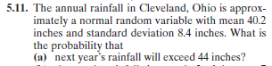
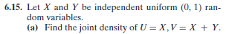
X and Y are independent and exponentially distributed with means of 5 and 7 respectively. Find the density function for X+Y.
X and Y are jointly continuous with joint density function, f(x,y) = 2e^{-2x}e^{-y+3}1{y>3, x>0}. Find the mean of Y.
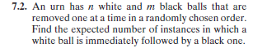

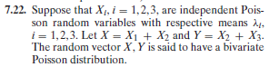
Find the correlation between X and Y.
