Input: Test seqs
Algorithms: Max(Differentiable Sequences), then Confidence Interval and Class Optimization w/ Tm Limits
Probe .GA--GA-G-A-A-CGA-CC--TC-T--AAA-CCC-G-CAC-GGGG.
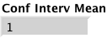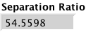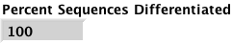

Input: Test seqs
Algorithms: Min(Sum of Tm Overlaps), then Confidence Interval and Class Optimization w/ Tm Limits
Probe .GA--GA-G-A-A-CGA-CC--TC-T--AAA-CCC-G-CAC-GGGG.
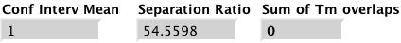

NOTE: Confidence Interval and Class Optimization by itself does not work with Test Sequences input. Without Tm Limits, it drops to very low Tms and with Limits it doesn’t iterate.

CICO w/o limits
Min(Overlaps)
Max(Diff Seqs)
Input: All seqs
Confidence Interval and Class Optimization w/o Tm limits.
With Tm limits, only goes thru 1 iteration then dies.
Probe:
.AAGACGA--GT-T-A-A-GGA-CC--TC-T--AAA-CCC-G-GCG-GGGGGAGT.
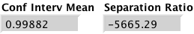

Input: All Seqs
Max(Percent Differentiable Sequences)
Probe .GA--GT-T-A-A-CTA-CC--TC-T--AAA-CCC-G-GTC-GGGGGCC.

WINDOWS:
Input: All Seqs
Max(Percent Differentiable Sequences)

Input: All Seqs
Min(Sum of Tm Overlaps)
Probe .GA--GT-T-A-C-CGA-CC--TC-T--AAA-CCC-G-CGC-GGGGGC.
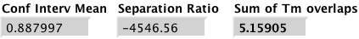

Input: All Seqs
CICO, then Min(Sum of Tm Overlaps)
Probe .AAGACGA--GG-T-A-A-GGA-CC--AC-T--AAA-CCC-G-GCT-GGGGGAGT.
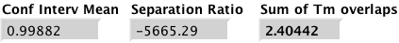

Input: All Seqs
CICO, then Max(Diff Seqs), then Min(Sum of Tm Overlaps)
Probe .AAGACGA--GT-T-A-A-GGA-CC--TC-T--AAA-CCC-G-GTC-GGGGGGGTC.

