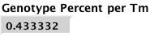 Weighted by number of copies/total.

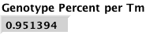This one is just doing a sum of the percents.

