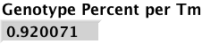 Assume population probability. Sum(max(Ci/sum(Ci))^2)
Probe: .AACA--AT-T-A-C-GGA-CC--TC-T--AAT-CCC-G-CAC-GGGGGCC.

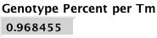 Assume equal probability for each genotype.
Sum(max((Ci/Gi)/sum(Ci/Gi))^2)
Probe: .A--GT-T-A-G-AGA-CC--AC-T--AAA-CCC-G-GTC-GGGGGCGGC.

