Project: Methodological (computational) probe design to differentiate Hepatitis C types 1 – 6.

Contact: Ian Odell / Carl Wittwer
Telephone: (801) 581-4738
Email: ido2@cornell.edu
Fax: (801) 581-4517
Address: Dept. of Pathology
University of Utah School of Medicine
Salt Lake City, UT 84132

Document Dates
Original: May 9, 2005

Goal:
Use the ARUP database of Hepatitis C sequencing to design a PCR primer and unlabeled probe system to differentiate types by probe melting temperature (Tm). Analysis will be done computationally, using ClusalX to align sequences and script programs written in LabVIEW and Perl for sequence extraction and analysis. Regions of desired probe characteristics as well as potential probes will be compared with previously published probes for Hepatitis C type differentiation. Use of sequences published on NCBI of the Hepatitis C genome will be used to check for any bias as a result of differential amplification from the ARUP primers.

Abstract:

The high variability of the Hepatitis C genome makes it an appropriate candidate for which to utilize a large database of sequence information to design probes computationally. The development of an efficient and reliable genotyping assay is a formidable if not impossible challenge without computational help and the development of a logical and well-defined methodology to analyze such a large database would be a novel and highly useful application to extend to other organisms. Based on analysis of the Hepatitis C genome (Second-Generation Line Probe Assay for Hepatitis C Virus Genotyping, Stuyver et al., 1996), the optimal genotyping region seems to be the 5’ untranslated region (UTR) because it contains enough conservation within and enough variation between, genotypes for a PCR genotyping assay. Sequences from January, 2002 to July, 2004 were extracted from the ARUP database. Included were types 1 – 6, subtypes 1a, 1b, 2a, 2b, 3a, 3b, 5a and 6a. Type designation was recorded by ARUP in their sequencing protocol. The methodology to analyze these sequences includes: separation of sequences by types, alignment, calculation of sequence frequencies within a type, analysis of highly represented sequences for desirable probe regions, and calculation of a weight matrix for each type. Further work will be done in implementing a probe design program.

Milestones:

- Extract sequences from ARUP database for January, 2002 to July, 2004.
- Calculate number of duplicates for all unique sequences and sort by highest frequency to lowest.
- Align all types using ClustalX.
- Check for duplicates across types.
- Calculate weight matrix for each type and display in a graphical plot.
- Locate desirable probe regions by analyzing highly represented unique sequences.
- Compared ARUP primers to Hepatitis C genomes published on NCBI.

TODO: Write a probe design program that maximizes the number of distinguishable groups by the probe Tm range with each type.

Methods:

1. Separate all sequences extracted from the ARUP database by type in order to analyze each type separately and distinguish as a group for probe design. Key identifiers in the names were found. For example, if the name contained ‘_1a’ or ‘_1b’, it was determined to be type 1. See perl code below.

#read the id of each sequence and add to its array accordingly
my $seq_id;
foreach my $seq (@seq_array) {
$seq_id = $seq->id;
#if sequence id contains 1a or 1b, add it to type 1 alignment
if ($seq_id =~ /_1a/ | $seq_id =~ /_1b/) {
push @type1, $seq;
} elsif ($seq_id =~ /_2a/ | $seq_id =~ /_2b/ | $seq_id =~ /_TYPE_2/) {
push @type2, $seq;
} elsif ($seq_id =~ /_3a/ | $seq_id =~ /_3b/ | $seq_id =~ /_TYPE_3/) {
push @type3, $seq;
} elsif ($seq_id =~ /_TYPE_4/) {
push @type4, $seq;
} elsif ($seq_id =~ /_5a/) {
push @type5, $seq;
} elsif ($seq_id =~ /_6a/) {
push @type6, $seq;
} else {
push @other, $seq;
}
}

2. Align sequences of each type using ClustalX. Open/extend gap penalties = 0 yields the best results because there is little variation among sequences within a type.

3. Count the number of duplicate sequences and append that number to the name of one, delete rest. This is actually done before and after the ClustalX alignment because doing it before saves on computation, especially for the 16,151 sequences in type 1. By counting the number of duplicates, we will get a representation of each unique sequence in our Hepatitis C 5’ UTR population.

Example output for one unique sequence:
>HCV-26240_1a_4215
--TA---G-T-A----T---G-A--G--TG-T---C----G-T--G-C-A-G-CC-T-CC-AGG---A-C-C-C--CCCC--T--CCC-GGG-A-G-A-GCCA-TA-GTGG-TC-T-GCGGAACC---GGTG-A-GT-ACA-C-CGG-AAT-T-GCC-AGGAC-G-A-C-CG-G-G-TCC--TTT--C--TT--GG---A---T------A---A--A---C-CC-GCT--CA-A-T-G-CCT-GG--AG-A--TTT-GGG-C-GTG-CCCCCGCAA-G-A-C-TG-CTAG-CCGAGTA-GT-GTT-GGG-T-CG--C--GAA---A-GG-C-C--T--T----G--T--GG--T---

As a check for the typing fidelity, all unique sequences were compiled into one file. Again, the number of unique sequences was calculated. Five sequences were clearly called the incorrect type because they were the exact same sequence called two different types. For example, there was one sequence that had 747 duplicates (very highly represented) called type 3 and one duplicate of the exact same sequence called type 1. The one type 1 sequence was clearly a miscalled type 3. This means that at least 5 of 21778 sequences were mistyped; a phylogenetic analysis of the sequences may reveal the rest.

4. A unique sequence is one that differs from all others by one or more bases; this may be an insertion, deletion, or SNP. Therefore, the presence of ambiguous bases gives us an overrepresentation of unique sequences; additionally, any ambiguous bases in the sequence may be caused by erroneous sequencing. For these reasons we removed all sequences with one or more ambiguous bases.

5. After having calculated the frequencies of unique sequences in each type, it is useful to see this in a graph. Each point on the x-axis is one unique sequence and its y value is its number of duplicates. The upper right-hand corner is zoomed in on the 20 sequences with the most duplicates.

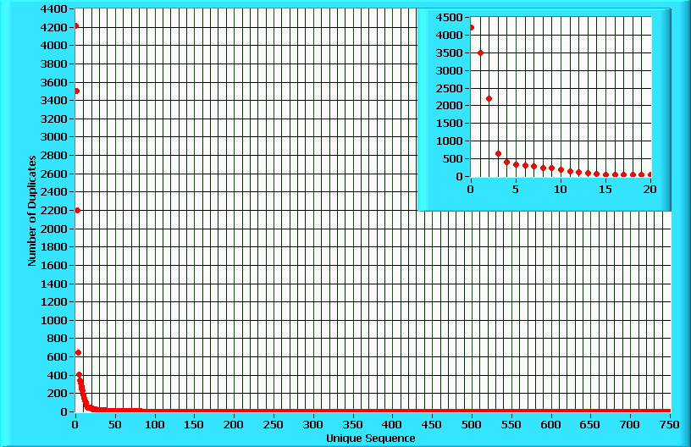
Graph of type 1 unique sequence frequencies.

An easier graph to analyze the frequency of each sequence is on log scale axes. It is almost linear, what we would expect for the distribution of random mutations in a population without selection over time. Note: this does not mean that Hepatitis C feels no selection, but rather that the 5’ UTR region of Hepatitis C feels little selection pressure with respect to its sequence variation.

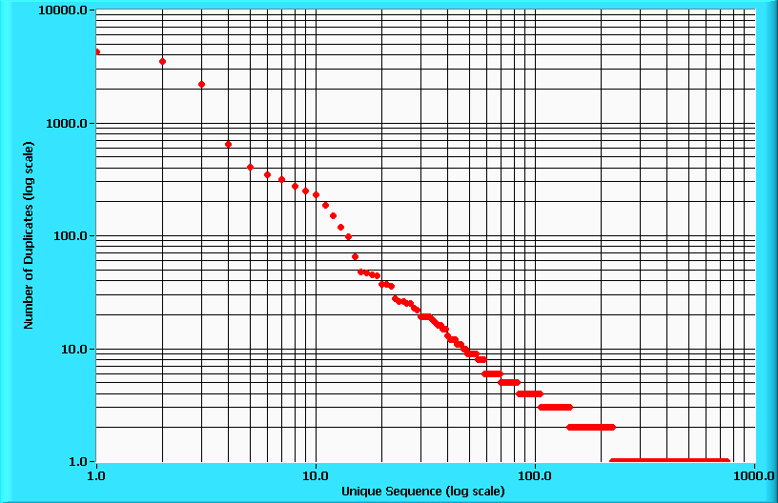
Graph of type 1 unique sequence frequencies on log scale x and y axes.

6. Each Hepatitis C type displays a similar linear log vs. log curve; therefore, some unique sequences are much more highly represented than the rest. By analyzing these highly represented sequences, a preliminary idea of bases that are conserved within a type and variable between types can be found. The most desirable probe region found in 5’ UTR is:
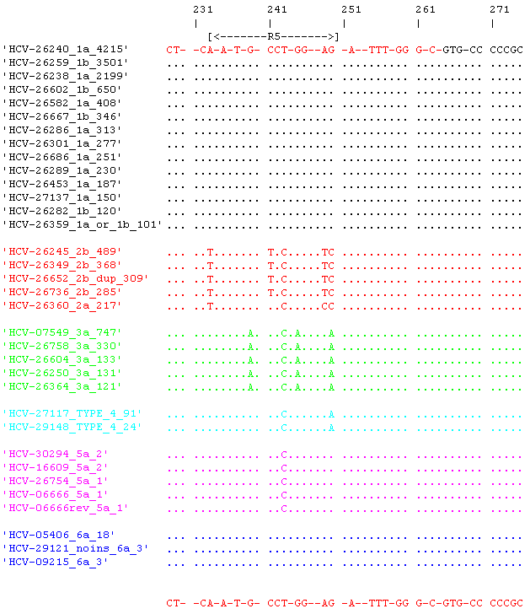
Preliminary desirable probe region.

Just by looking at conserved bases within a type and variable between types, one can see that types 1 and 6, 2, 3, 4, and 5 are distinguishable. The R5 designation of the variable region refers to “Second-Generation Line Probe Assay for Hepatitis C Virus Genotyping,” by Stuyver et al. which looked at twenty-one different probes over seven regions and found six selected probes over R5 to differentiate types 1, 3, 4 and 10, and 5, as well as for subtypes for 2a/2c, 2b, and 3b. These experimental results confirm the computational analysis done thus far and that analyzing the most highly represented sequences is an informative exercise.
Additionally, looking at the highly represented sequences in our database revealed that probes from two other publications (“Genotyping of Hepatitis C Virus Types 1, 2, 3, and 4 by a One-Step LightCycler Method Using Three Different Pairs of Hybridization Probes,” Schroter et al., 2002, and “Hepatitis C Genotype Determination by Melting Curve Analysis with a Single Set of Fluorescence Resonance Energy Transfer Probes,” Bullock et al., 2002) do not account for common SNPs because they did not analyze a database with as much information. This confirms that the ARUP database is better than the ones used in previous publications because it is larger. For this reason, probes designed in this project should be the most reliable in Hepatitis C genotyping.

7. In order to see how the desirable probe region looks for all sequences of each type, a weight matrix was created for each type. In a weight matrix, each column is an index of the sequence and each row is a base’s percentage of all the sequences of that type. This allows use to analyze the variation within and between types for each individual base.

 | 1 | 2 | 3 | 4 | 5 | 6 | 7 | 8 | 9 | 10
A | 0.000433 | 0.999752 | 0.000124 | 0.000186 | 0 | 0 | 0.999629 | 0 | 0 | 0.000124
C | 0 | 0 | 6.20E-05 | 6.20E-05 | 6.20E-05 | 6.20E-05 | 0 | 6.20E-05 | 6.20E-05 | 0
G | 6.20E-05 | 0 | 0.000124 | 0.999567 | 0.000495 | 0 | 6.20E-05 | 0.000186 | 6.20E-05 | 0.000186
T | 0.999257 | 6.20E-05 | 0 | 0 | 0.998824 | 6.20E-05 | 0.000248 | 6.20E-05 | 0.999629 | 6.20E-05
DASH | 0.000186 | 0.000124 | 0.99969 | 0.000124 | 6.20E-05 | 0.999876 | 6.20E-05 | 0.99969 | 0.000124 | 0.999629
AMBIG | 6.20E-05 | 6.20E-05 | 0 | 6.20E-05 | 0.000557 | 0 | 0 | 0 | 0.000124 | 0
Example weight matrix for the first 10 bases of type 2:

8. In order to visually analyze a weight matrix, a plot of each matrix was made, where any base with a value greater than zero is shown as a dot on a scale from zero to one, one being complete conservation of that base in all sequences.

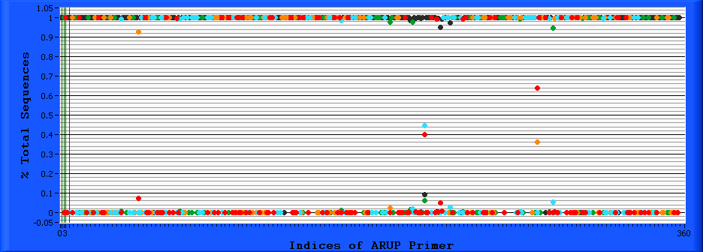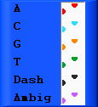
[ R5 ] →]
[ R5 ] →]
Graphical weight matrix for Hepatitis C type 1.

The R5 region is shown on the type 1 graphical weight matrix. The bases to the 3’ end of it are the most highly conserved if the entire sequence. R5 is therefore an even stronger candidate to include in a probe.

9. Up to this point, we have isolated a desirable probe region within the 5’ UTR. This process would be facilitated by automating it into a single computer program since the logical steps have been worked through individually. Before achieving this however, a program to specify a single probe over our chosen region is the final step of the methodology. An algorithm that maximizes the number of non-overlapping probe Tm ranges with each sequence group is in the works.

ARUP Primer Analysis:
In order to see if the ARUP primers bias the database in any way, all Hepatitis C complete genome sequences were downloaded from GenBank. Blasting the primers alone was not an appropriate task because a Blast search returns most similar sequences and sequence variation underneath the primers was the desired information. 239 genomes were found and then aligned. Shown below are the variations underneath the forward (5’-GCAGAAAGCGTCTAGCCATGGCGT-3’) and reverse (reverse complement: 5’-ACTGCCTGATAGGGTGCTTGCGAG-3’) primers.

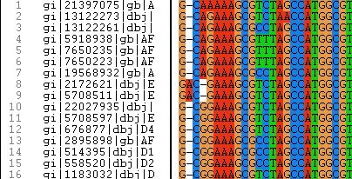
ARUP forward primer.

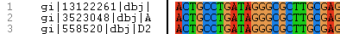
ARUP reverse primer.

The reverse primer has just one SNP in 3/239 sequences 15 bases from the 3’ end. The forward primer has a few SNPs and two insertions. The nearest SNP is 10 bases from the 3’ end and no primer variant contains more than one SNP or insertion, so the sequence data from NCBI confirms that the ARUP primers are acceptable. One modification to test is extending the forward primer a few bases to its 3’ end, bases that are shown to be conserved in the NCBI data (see graphical weight matrix).

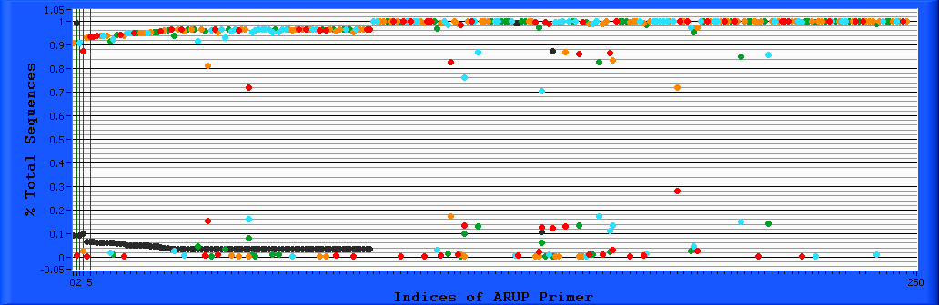
[ Reverse ]
[ Forward ]→]
[ Reverse ]
[ Forward ]→]
Graphical weight matrix of ARUP amplicon from NCBI sequences.

