Revised November 8, 2018
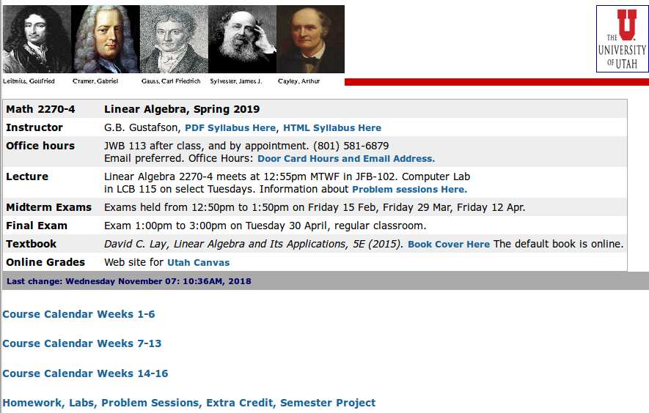

OFFICE, PHONE, EMAIL: JWB 113, 801-581-6879,

Course: http://www.math.utah.edu/~gustafso/s2019/2270/index2270S2019.html
Door Card: http://www.math.utah.edu/~gustafso/doorcardS2019.pdf
CANVAS: https://utah.instructure.com/
Book Cover:


Hardcover: 576 pages
Pearson; 5th edition 2015
ISBN-10: 032198238X and
ISBN-13: 978-0321982384

