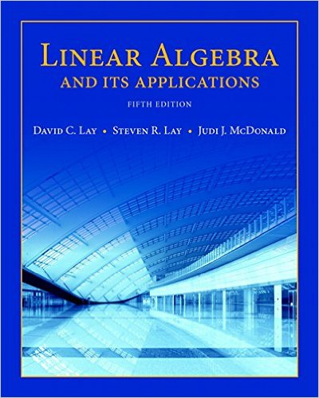

Hardcover: 576 pages
Publisher: Pearson; 5 edition (January 3, 2015)
ISBN-10: 032198238X and ISBN-13: 978-0321982384

