Colin McNabb
Math 2270
Professor Gustafson
Biochemical Pathways as Linear Systems
Introduction:
The human body is an extremely complex system, especially when you look at it from a chemical standpoint. You have thousands of reactions happening constantly within each cell, of which there are trillions, in your body. Every time you make the slightest movement, smell something, see something, or even just simply sit still, your body is working at dizzying rates to keep you alive and able to function. One of the most basic reactions, and the one I will be examining, is cellular metabolism. Cellular metabolism is the process of taking glucose, the preferred source for fuel in the body, and converting it to carbon dioxide, water and, most importantly, Adenosine Triphosphate (ATP). The amazing thing about biochemistry is that it can be easily modeled in a linear system. Using systems of linear equations we can create stoichiometric matrices based on the individual chemical equations and use these matrices to determine the overall net reaction involved in this chemical pathway.

Chemical Reactions of Metabolism:
1. glucose + ATP = glucose 6-phosphate + ADP
2. glucose 6-phosphate = fructose 6-phosphate
3. fructose 6-phosphate + ATP = fructose 1,6-bisphosphate+ ADP
4. fructose 1,6-bisphosphate = glycerone phosphate + glyceraldehyde 3-phosphate
5. glycerone phosphate = glyceraldehyde 3-phosphate
6. glyceraldehyde 3-phosphate + Pi + NAD⁺ = 3-phospho-D-glyceroyl phosphate + NADH
7. 3-phospho-o-glyceroy1 phosphate+ ADP= 3-phospho-D-glycerate + ATP
8. 3-phospho-D-glycerate = 2-phospho-D-glycerate
9. 2-phosphoglycerate = phosphoenolpyruvate +H2O
10. phosphoenolpyruvate + ADP = pyruvate+ ATP
11. pyruvate + CoA + NAD⁺ = acetyl-CoA + CO2 + NADH
12. acetyl-CoA + oxaloacetate + H20 = citrate + CoA
13. citrate = cis-aconitate+ H2O
14. cis-aconitate+ H20 = isocitrate
15. isocitrate + NAD⁺ =2-oxoglutarate + CO2 + NADH
16. 2-oxoglutarate + NAD⁺ + CoA = succinyl-CoA+ CO2+ NADH
17. succinyl-CoA + Pi + ADP = succinate + ATP + CoA
18. succinate + NAD⁺ = fumarate + NADH
19. fumarate + H2O = (S)-malate
20. (S)-malate + NAD⁺ = oxaloacetate + NADH
21. NADH + 1/2O2 + 3Pi + 3ADP = NAD⁺ + 4H20 + 3ATP

For future clarity, Pi is inorganic phosphate which, when bound to another molecule, is a source of a high energy bond, which, when broken, can be a source of the energy required for the formation of new bonds between substrates; ADP is Adenosine Diphosphate, which is ATP with one phosphate group removed as Pi.
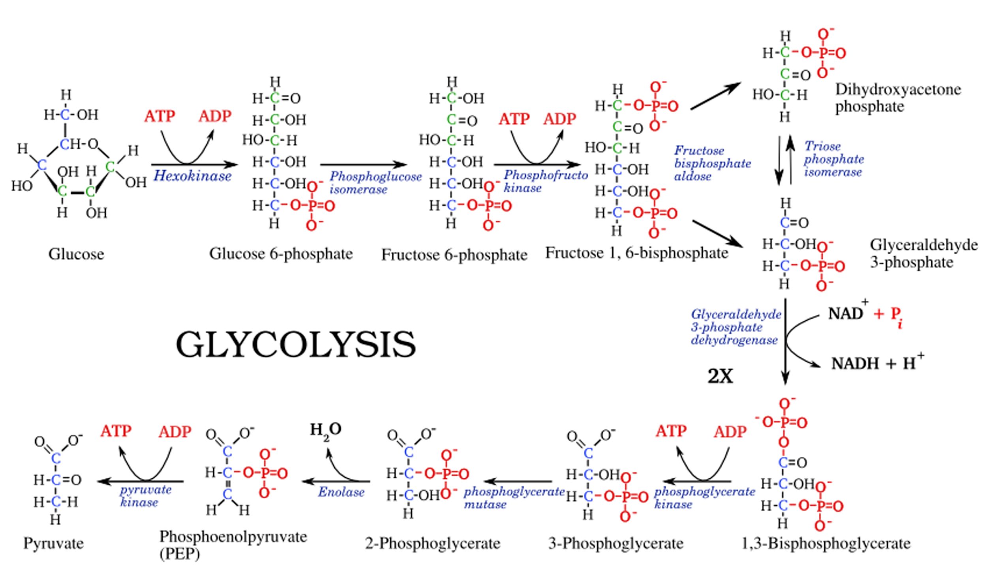

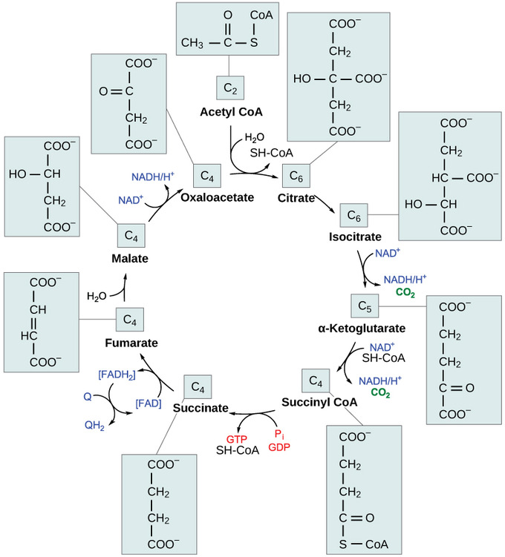

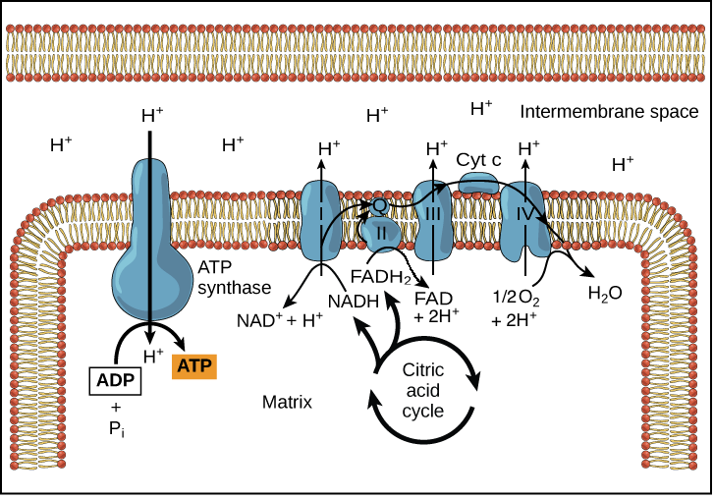

Mathematics Behind Metabolism:
The calculation of a biochemical pathway through linear algebra is done with a stoichiometric number matrix. This is a matrix which gives the stoichiometric number for the various molecules encountered in an independent reaction. In these matrices, the number of rows is determined by the number of substrates encountered in a pathway, and the number of columns is determined by the number of reactions involved in an overall pathway. In each individual reaction, the reactants will be given a (-) in front of their stoichiometric number because they are being consumed, while the products will have a (+) stoichiometric number. This matrix can then be multiplied by a column vector, which is called the pathway vector. The pathway vector will have a row for each reaction (or column) of the number matrix. For a given set of reactions a solution will not always exist. The solution will only exist when the final column of the number matrix is a linear combination of the columns of the number matrix.
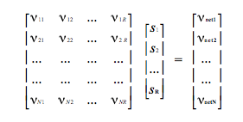
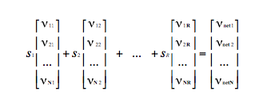
The trick with this system is that it is easy to calculate the net energy production when you can multiply a number matrix by a pathway vector, but what if you don’t know the pathway vector? This seems like the kind of roadblock that could stop an aspiring mathematician right in their tracks. Luckily, there is a workaround. We can create a stoichiometric number matrix without any of the reactions involving energetic molecules, namely Pi, ADP, ATP, NADH, NAD⁺. We can then simplify these reactions down to their lowest stoichiometric number, which can provide a pathway vector for the abbreviated matrix. This will not balance any energetic molecules, but it will allow us to balance the carbon, oxygen and sulfur used. This will generate pathway vectors which we can then use to calculate a net energy output for the metabolism depending on starting substrates.

To save on space, and because this is a lesson mostly on math and not the biochemistry possibilities, I will only include 3 of the possible pathways. One starting from glucose, one starting from a phosphorylated version of glucose, and one coming from an already partially oxidized species stemming from glucose. The rows of the unabbreviated matrix will go in the following order of molecular species, while the abbreviated matrix will simply follow in the same order with the energetic molecules removed:

- Glucose
- Pi
- ADP
- NAD⁺
- Pyruvate
- ATP
- NADH
- H2O
- CoA
- Acetyl-CoA
- CO2
- O2
- Glucose 6-phosphate
- Fructose 6-phosphate
- Fructose 1,6-bisphosphate
- Glycerone phosphate
- Glyceraldehyde 3-phosphate
- 3-phospho-D-glycerol phosphate
- 3-phospho-D-glycerate
- 2-phospho-D-glycerate
- Phosphoenolpyruvate
- Oxaloacetate
- Citrate
- Cis-aconitate
- Isocitrate
- 2-oxoglutarate
- Succinyl-CoA
- Succinate
- Fumarate
- Malate

We can take the abbreviated number matrix and the 3 simplified net reactions and relate these to each other with the matrix equation: Ax=b. In this example, A is the number matrix, b is the matrix made up of vector representations of the simplified net reactions, and x, which is typically a column vector, will be the reaction pathway we wish to solve for.

The abbreviated number matrix will be denoted by matrix A:

We will denote the abbreviated net reactions by the matrix B:
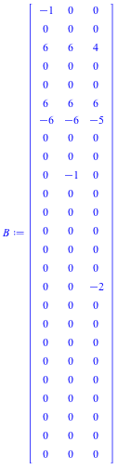

glucose + 6 O2 = 6 CO2 + 6 H2O

fructose 1,6-bisphosphate + 6 O2 = 6 CO2 + 6 H2O

5 O2 + 2 phosphoenolpynrvate = 6 CO, + 4 H2O

By using the LinearSolve tool in Maple, we can determine the Matrix, C, of pathway vectors that can relate A to B:
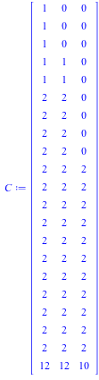

One observation that in hindsight seems obvious is the fact that the first 20 rows of matrix C correspond to how many times substrate passes through each enzyme that catalyzes that step. This makes perfect sense when you think about what exactly a pathway vector represents. The pathway vectors represent how many times each of the 20 reactions of glycolysis and the citric acid cycle occur per one starting material. The final row represents the ATP generated through oxidative phosphorylation, or the electron transport chain, which is itself dependent on the quantities of byproducts from the first 20 reactions.
This pathway matrix balances the reaction with regards to the “non energetic” atoms such as carbon, oxygen, and phosphates when they are attached. Because the energetic molecules are attached to these reactions, we can then add them back into the number matrix and determine their output.

The unabbreviated number matrix is represented by matrix A1:

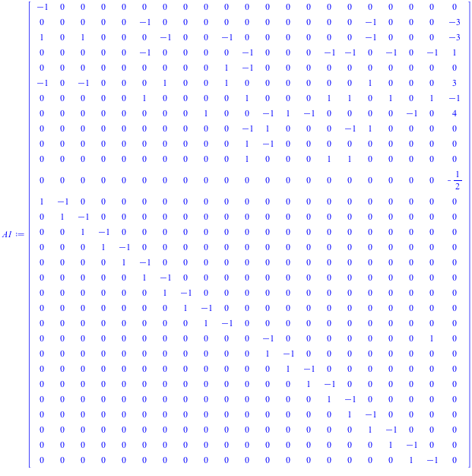

We can then use matrix multiplication to observe the overall net reactions of glycolysis:

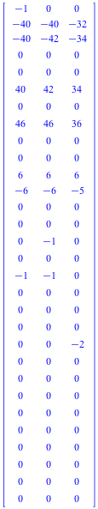
A1*C⇒

40 ADP + glucose + 6 O2 + 40 Pi = 40 ATP + 6 CO2 + 46 H2O

42 ADP + fructose 1,6-bisphosphate + 6 O2 + 40 Pi = 42 ATP + 6 CO2 + 46 H2O

34 ADP + 5 O2 + 2 phosphoenolpyruvare + 32 Pi , 34 ATP + 6 CO, + 36 H2O

We can now compare the values in row 6 to compare the ATP generated per 1 molecule of starting material.

Conclusion:
Using the example of metabolism, which is fairly complex but by no means the most complex chemical reaction the body undergoes, we can see that as long as certain aspects of a chemical pathway are known that we can model it in a linear system. Once we have a linear representation of it, we can then use simple matrix properties to solve for any unknown or desired quantities.

References:
Alberty, R.a. "Calculation of Biochemical Net Reactions and Pathways by Using Matrix Operations." Biophysical Journal 71.1 (1996): 507-15. Web.
Akinola, R. O., S. Y. Kutchin, I. A. Nyam, and O. Adeyanju. "Using Row Reduced Echelon Form in Balancing Chemical Equations." Advances in Linear Algebra & Matrix Theory06.04 (2016): 146-57. Web.
Rhodes, Carl Douglas, Kirsten Fertuck, P. David Josephy, Roger E. Koeppe, and Jeremy M. Berg. Biochemistry, Eighth Edition. New York: W.H. Freeman and, a Macmillan Education, 2015. Print.
Lay, David C., Steven R. Lay, and Judi J. McDonald. Linear Algebra and Its Applications. Boston: Pearson, 2016. Print.
"Oxidative Phosphorylation." Khan Academy. N.p., n.d. Web. 18 Apr. 2018.
"Glycolysis." Khan Academy. N.p., n.d. Web. 18 Apr. 2018.
"The Citric Acid Cycle." Khan Academy. N.p., n.d. Web. 18 Apr. 2018.

