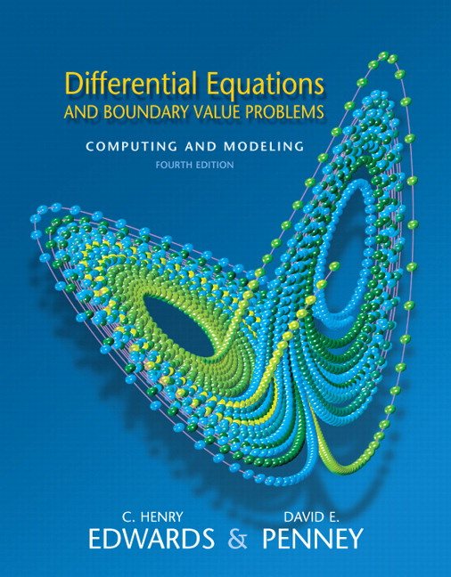
Differential Equations and Boundary Value Problems: Computing and
Modeling, 4/E.
C. Henry Edwards
David E. Penney, University of Georgia, Athens
ISBN-10: 0131561073 • ISBN-13: 9780131561076
©2008 • Pearson • Cloth, 816 pp
Published 07/26/2007
Edition 4/E will be used in the course 2270-2. The bookstore sells 5/E, below. The major difference is added section 5.3.

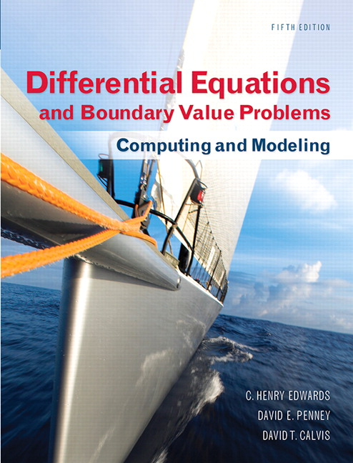
Differential Equations and Boundary Value Problems: Computing and
Modeling, 5/E
C. Henry Edwards
David E. Penney, University of Georgia, Athens
David Calvis, Baldwin-Wallace College
ISBN-10: 0321796985 • ISBN-13: 9780321796981
©2015 • Pearson • Cloth, 792 pp
Published 09/04/2014 •
There exists edition 5/E with the same cover, same authors, but title missing the words
“Boundary Value Problems” and fewer pages. Wrong book, wrong ISBN, don't buy it!

Suggested retail price: $211.20

