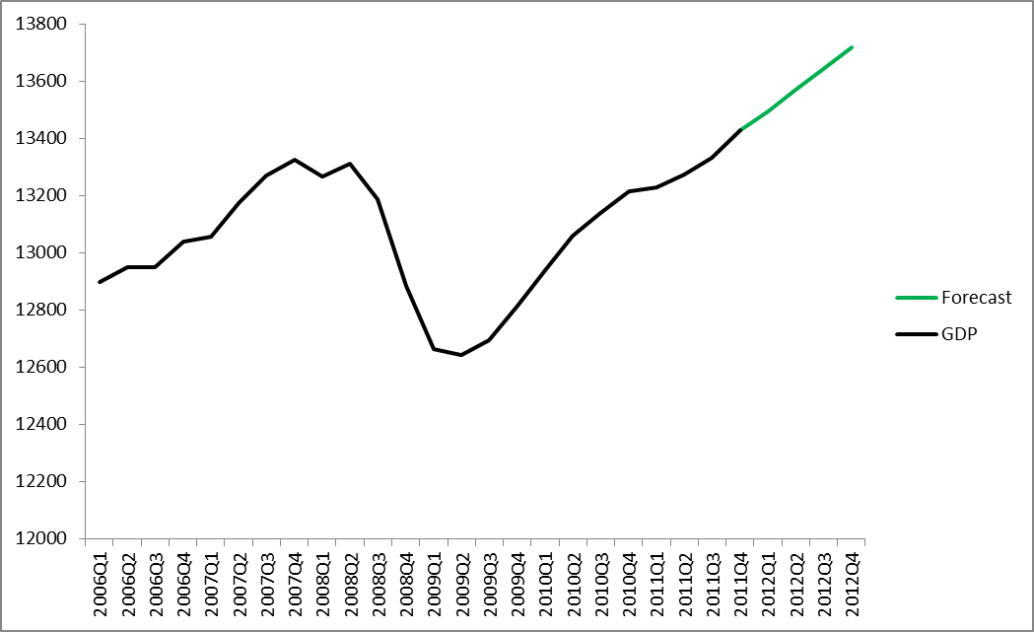
Forecasting Real GDP with Linear Algebra
ऀGross Domestic Product (GDP) is a measure of the total output produced in an economy. It is a measure of the size of an economy in terms of economic activity. The nominal value of the United States economy is currently around 14 trillion dollars per year. The United States has the largest economy of any individual country in the world, although if the countries in the European Union were counted as a single entity it would have a larger GDP (and hence a larger economy) than the United States. Inflation increases the prices of goods and therefore GDP in later years after inflation has occurred can be exaggerated if one wants to compare the economic activity occurring within a country from year to year. Therefore, GDP is often measured in a way that adjusts for inflation. This is done by choosing a base year and expressing GDP for all years in terms of the value of a dollar in that base year rather than the actual nominal values. This new figure of GDP, which can be compared with other years, is called Real GDP. From now on when we mention “GDP” we will be referring to real GDP.
ऀOur goal for this project is to do a simple forecast of GDP with a method that utilizes some of the linear algebra covered in class this term. The Federal Reserve Bank of the United States releases information about the United States economy on a regular basis. The first quarter data for GDP in 2012 will be released on Thursday March 29th. We will make a forecast using a method that involves least squares approximations. Our forecast will include a forecast for the data to be released on the March 29th2012 as well as some periods after that. When the first quarter data is released (prior to the due date for this assignment) we will be able to compare our forecast with the actual numbers. The rest of this write up will focus on the method used to do the forecast and the linear algebra involved.
ऀThe forecasting method we use is known as a vector autoregression (VAR). A VAR is a statistical model that can be used to forecast time series variables. Each of the time series variables within a VAR model is called an endogenous variable. Variables like constants or time trend variables are called exogenous variables. There is one equation in the VAR for each endogenous variable. Each such equation explains the progression of its endogenous variable in terms of that variable’s own past values as well as past values of the other endogenous variables in the model.
ऀWe include three time series variables in our VAR: real GDP, total US capacity utilization, and the treasury yield (interest rate) on three month treasury bills. These are the endogenous variables. There is one equation in the VAR for each of these three variables. That equation explains the value of its variable as a function of previous values of all three endogenous variables and one exogenous constant term:
Define:
G:= GDP
C:= Capacity Utilization
R:= Treasury Bills (3 month)
Then our VAR has three equations, one for each of these variabes:
G_{t}= α_{g}+β_{g1}G_{t-1} +β_{g2}G_{t-2} +β_{g3}C_{t-1} +β_{g4}C_{t-2} +β_{g5}R_{t-1} +β_{g6}R_{t-2} +ε_{gt}
C_{t} = α_{c}+β_{c1}G_{t-1+}β_{c2}G_{t-2} +β_{c3}C_{t-1} +β_{c4}C_{t-2+}β_{c5}R_{t-1} +β_{c6}R_{t-2} +ε_{ct}
R_{t} = α_{R}+β_{R1}G_{t-1} +β_{R2}G_{t-2} +β_{R3}C_{t-1} +β_{R4}C_{t-2} +β_{R5}R_{t-1} +β_{R6}R_{t-2} +ε_{Rt}

ऀAs can be seen above, the VAR models each of the endogenous variables as functions of past values of themselves and the other endogenous variables (and a constant and error term). For example GDP at time t is a function of a constant with coefficient α_{g}, the value of GDP at time t-1, the value of GDP at time t-2, the value of capacity utilization at time t-1, the value of capacity utilization at time t-2, the value of the treasury yield at time t-1, the value of the treasury yield at time t-2 and an error term. Each of the endogenous variables has a similar equation, however the coefficients are different in each equation.
ऀThe idea of forecasting with a VAR model is as follows: determine the coefficients in the system of equations (one equation for each endogenous variable) and then forecast the future values of the variables using that system of equations. Because the values of the endogenous variables in the VAR are functions of their previous values and constants, we can forecast their values at time t+1 once we know the values of the coefficients. This is done by plugging in the appropriate past values of the endogenous variables. This gives us a one step ahead forecast. We then assume that the forecasted values at t+1 are “correct” and then those values can be used to forecast time t+2 (at which time their values would be inserted in to the appropriate places for which they are now time t-1 values). Therefore, all that is needed to forecast the variables in the VAR (GDP is the one we are interested in here) is their known values during each previous time period and the values of the coefficients in the system of equations.
ऀThe values of the coefficients in the VAR are solved for with linear algebra. This is done via least squares approximations. We must do three least squares approximations: one for each equation in the VAR. To see how this is done we will examine the least squares approximation for the GDP at time t equation in the VAR. We considered GDP from 1992 up until the most recent known value of GDP (its 2011 quarter 4 value). We must set up a matrix equation that we can solve for the coefficients that have the “best fit” for the model. Our matrix interpretation of the GDP equation has one equation for each value of t (one for each quarter that GDP was released from 1992 to 2011):
G_{2011Q4} = α_{g}+β_{g1}G_{2011Q3} +β_{g2}G_{2011Q2} +β_{g3}C_{2011Q3} +β_{g4}C_{2011Q2} +β_{g5}R_{2011Q3} +β_{g6}R_{2011Q2} +ε_{g2011Q4}
G_{2011Q3} = α_{g}+β_{g1}G_{2011Q2} +β_{g2}G_{2011Q1} +β_{g3}C_{2011Q2} +β_{g4}C_{2011Q1} +β_{g5}R_{2011Q2} +β_{g6}R_{2011Q1} +ε_{g12011Q3}
…
G_{1992Q4}= α_{g}+β_{g1}G_{1992Q3} +β_{g2}G_{1992Q2} +β_{g3}C_{1992Q3} +β_{g4}C_{1992Q2} +β_{g5}R_{1992Q3}+β_{g6}R_{1992Q2} +ε_{g1992Q4}

Our goal is to determine the coefficients (α_{g},β_{g1,…} β_{g6}). Thus we have Ax=b. b is a column vector where component one is GDP at time 2011 quarter 4, component 2 is GDP at time 2011 quarter 3, and so on until finally the last component is GDP at the first observation during 1992. Similarly A is a matrix consisting of a column of ones for the constant, a column of the values of GDP at time t-1, a column of GDP at t-2, and four more similar columns for the lagged values of C (capacity utilization) and R (three month treasury yields) at times t-1 and t-2. The coefficients we wish to determine make up the column vector x. The first component is α_{g}, the next is β_{g1}, and so on with the last component of x being β_{g6}. Note: if A is an n by m matrix, column vector x has m components and column vector b has n components.
The error terms, the ε’s in the equations above, are not included in the Ax=b equation we are considering. The error terms are the amount by which the value of GDP at time t differs from the value of the function to the right of GDP in the VAR system when the error term is not included. We find the “best fit” by determining the coefficients that minimize the error. This is where least squares approximation comes into play. Because b is not in the column space of A, Ax=b is not solvable. Instead we solve A*(xhat)=p, where p is the projection of b onto the column space of A. This “xhat” is the coefficient vector that contains, as components, the coefficients that minimize the error and have the “best fit” for the model –“xhat” contains the coefficients for GDP in the VAR model. In Maple, we then solve for this “xhat” vector of coefficients. This is done with the usual least squares method. With the matrices and vectors described above, we have (xhat)=(A^{T}A)⁻¹A^{T}b. This is how the coefficients for the GDP equation in the VAR are solved for. The resulting error vector is in the left nullspace of A and is perpendicular to p; it is the smallest possible error vector. The same method was used to find the coefficients of the other equations in the VAR.
The procedure described above was performed for each of the equations in the VAR to solve for the coefficients in the VAR model. Then the forecast was performed using the one step ahead method described above. Each variable was therefore forecasted into the future with one step ahead forecasts. Our goal was to forecast GDP so we will only report the GDP forecast. It is found directly below:

ऀNote1: We used the first difference of logs for GDP and the first difference of capacity utilization. The GDP forecast was converted back to real GDP terms for the above forecast results.
ऀNote2: This is the general procedure for performing such a vector autoregression forecast. We did not detail some of the more complicated statistical details involved with performing such a forecast (such as making sure the model is stable by checking a condition on the moduli of its roots). However, we did check these details via Eviews, a statistics program, in order to ensure we had chosen a valid model with appropriate coefficients and a sufficient number of lags. Needless to say, we are not expert econometricians. Our forecast may well be off; the actual quarter 1 2012 GDP data will be released on Thursday March 28 for comparison with our forecast. Lastly, the further out forecasts were done for illustrative purposes. Usually the first one or two data points into the future would be of most interest for forecasting in such a way.
Note 3: We will attach all of our maple files used to perform the calculations. The coefficients generated in maple were checked by estimating the same VAR with Eviews statistical software and they were correct.

