Jessica Murdock
MATH 2270 Spring 2016
U0973401

Image Manipulation Using Mathematica

Wolfram Alpha’s programming language can be used for various purposes, including changing and creating images that can later be exported to your file system. This is possible largely through the use of vectors, matrices and arrays to represent the different aspects of the image. For example, given the image below, the dimensions can be given as a vector.

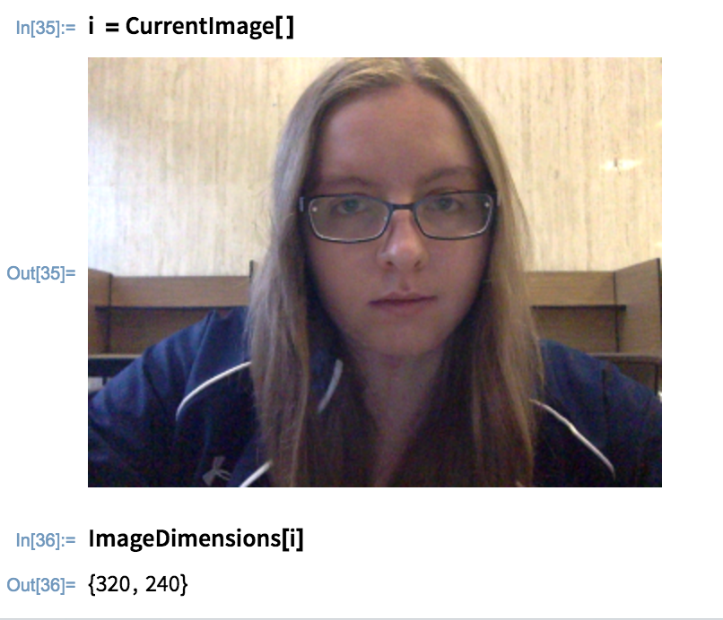

A matrix or a multidimensional array can also be used to represent the colors of each individual pixel in this image:
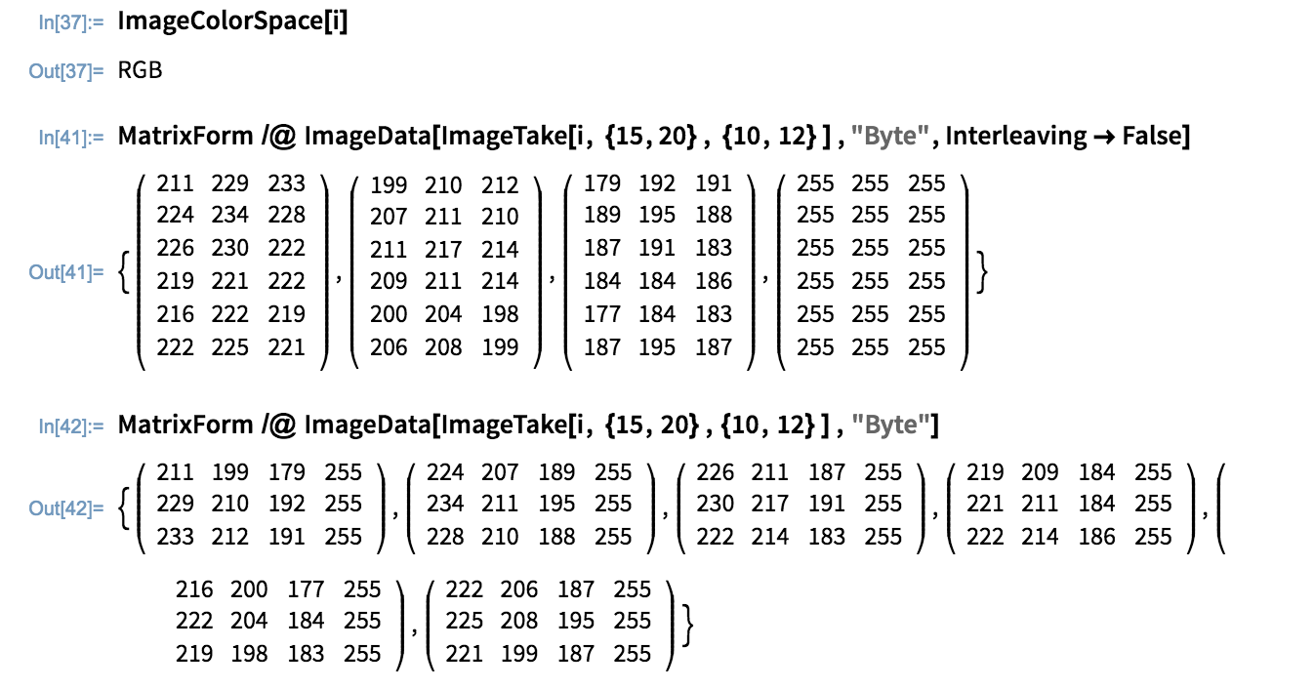
In the first set of matrices above, the rows of each matrix correspond to pixels 15 through 20 from the left edge of the image, and the columns correspond to pixels 10 through 12 from the bottom edge of the image. The last matrix represents the highest value possible for each color channel (Red, Green, and Blue) in each pixel: 255. The other three matrices represent the actual values of each color channel for each pixel. The pixel 15 pixels from the left and 10 pixels from the bottom, for example, has a value of 211 for red coloring, 199, for green, and 179 for blue.
In the second set of matrices, the last column of each matrix show the maximum value possible in each entry, while the other columns represent RGB values. The first matrix shows the values of pixels 10 through 12 from the bottom and 15 pixels from the left, the second shows pixels 10 through 12 from the bottom and 16 pixels from the left, and so on. These two sets of matrices are different ways of representing the colors of each specified pixel in the image.
Mathematica can take this representation further by separating an image according to color channels. In the example below, only red is pulled out of the image.
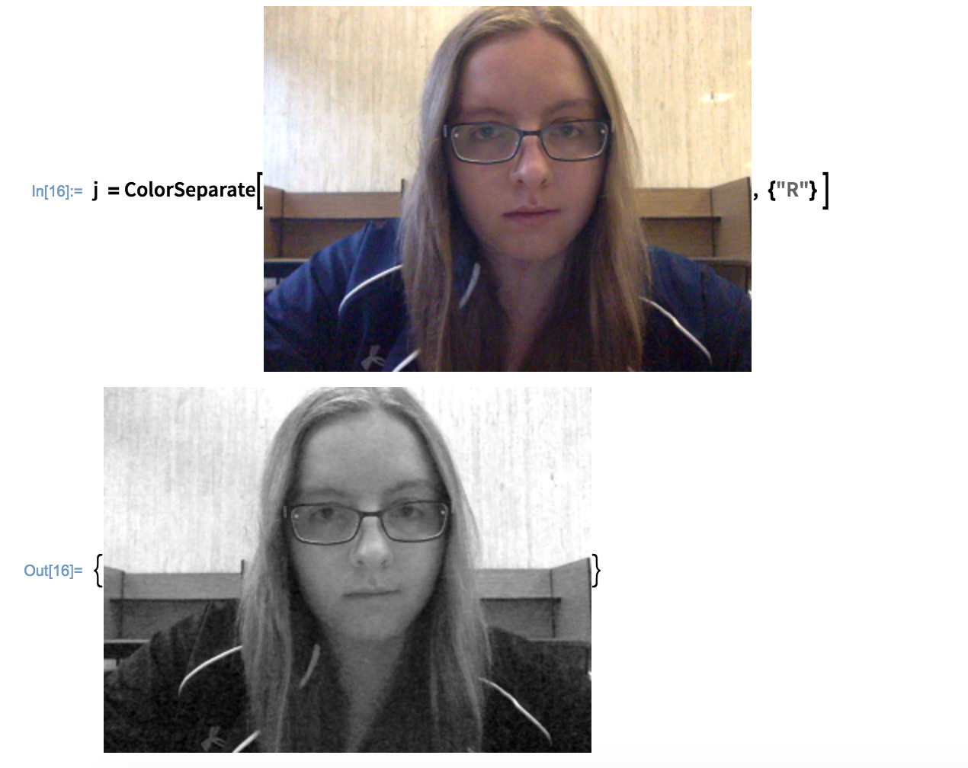
However, if a digital RGB image like this one needed to be printed, it would need to be converted to CMYK colors, as printers don’t use red, blue, and green ink:
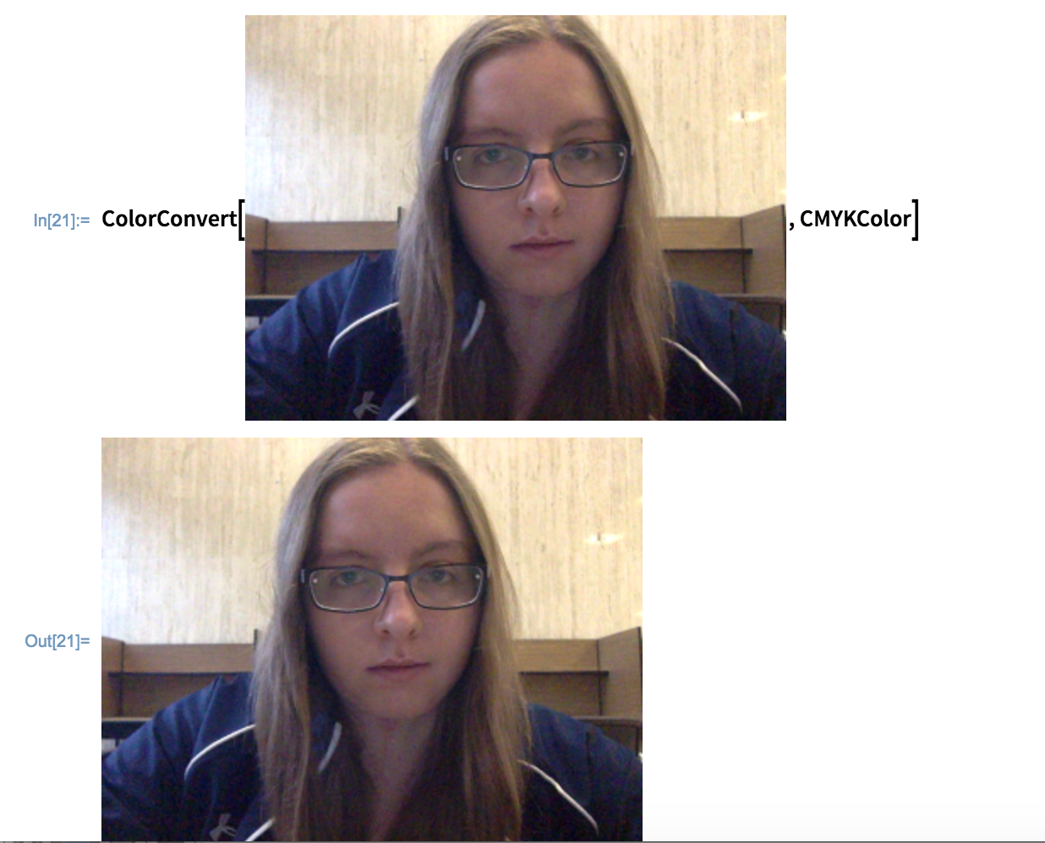
The new image looks almost exactly the same, but can be separated into cyan, magenta, yellow, and black values for a printer to read.
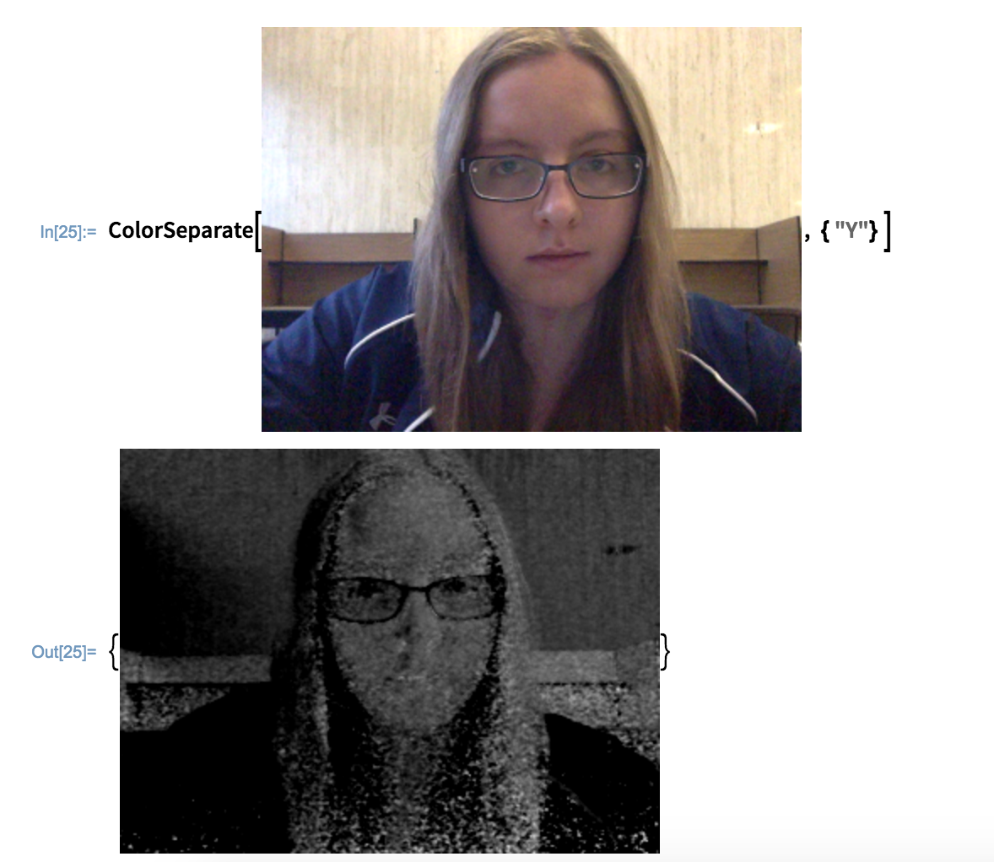

Works Cited
"Color Processing." —Wolfram Language Documentation. N.p., n.d. Web. 31 Mar. 2016. <http://reference.wolfram.com/language/guide/ColorProcessing.html>.
"ColorConvert." —Wolfram Language Documentation. N.p., n.d. Web. 29 Mar. 2016.
"ColorSeparate." —Wolfram Language Documentation. N.p., n.d. Web. 30 Mar. 2016.
"EasyBib: The Free Automatic Bibliography Composer." EasyBib. N.p., n.d. Web. 30 Mar. 2016. <http://www.easybib.com/>.
"Image Processing." —Wolfram Language Documentation. N.p., n.d. Web. 30 Mar. 2016. <https://reference.wolfram.com/language/tutorial/ImageProcessing.html>.
"Image Representation." —Wolfram Language Documentation. N.p., n.d. Web. 31 Mar. 2016. <https://reference.wolfram.com/language/guide/ImageRepresentation.html>.
"ImageData." —Wolfram Language Documentation. N.p., n.d. Web. 31 Mar. 2016. <https://reference.wolfram.com/language/ref/ImageData.html>.
"ImageLines." —Wolfram Language Documentation. N.p., n.d. Web. 31 Mar. 2016. <https://reference.wolfram.com/language/ref/ImageLines.html>.
"MatrixPlot." —Wolfram Language Documentation. N.p., n.d. Web. 31 Mar. 2016. <https://reference.wolfram.com/language/ref/MatrixPlot.html>.
"RGBColor." —Wolfram Language Documentation. N.p., n.d. Web. 29 Mar. 2016.
Wolfram, Stephen. An Elementary Introduction to the Wolfram Language. N.p.: n.p., n.d. Preface: Elementary Introduction to the Wolfram Language. Web. 30 Mar. 2016. <http://www.wolfram.com/language/elementary-introduction/preface.html>.

