Veronica Dean-Perry
MATH 2270
Dr. Gustafson
Spring 2016
Using Weighted Least Squares to Model Data Accurately
Linear algebra has applications across many, if not all, mathematical topics. For example, linear algebra can be used in statistical examination in order to make inferences about samples or populations. Unfortunately, data sets aren’t always the most accurate reflections of the true values within a population. Certain survey techniques, such as self-reporting, can contain bias and will alter the prediction reliability of the data. Luckily, there are procedures that can be done to account for bias in order to attempt to get the most accurate picture of the data we are given.
Considering the height and weight data given in Lab 3 from a previous Linear Algebra class, we understand that the data was more than likely self reported. Below is a scatterplot with each point corresponding to a point within the data set.

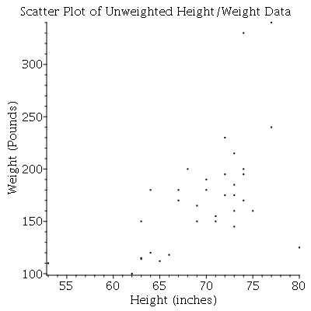

In order to predict the expected weight for a given height, we must create a least squares regression model, which will create a linear equation for which we can plug in height values, given variable x, to calculate an expected weight, given variable y. The commonly used matrix equation Ax=b is often used to do so. This matrix equation can be rewritten as Xß=y where X, and y correspond to the following matrices.

X=$\left[\begin{matrix}1 & 77 \\ 1 & 72 \\ 1 & 64 \\ 1 & 73 \\ 1 & 69 \\ 1 & 64 \\ 1 & 72 \\ 1 & 67 \\ 1 & 65 \\ 1 & 73 \\ 1 & 74 \\ 1 & 73 \\ 1 & 75 \\ 1 & 66 \\ 1 & 74 \\ 1 & 80 \\ 1 & 63 \\ 1 & 68 \\ 1 & 53 \\ 1 & 63 \\ 1 & 71 \\ 1 & 62 \\ 1 & 77 \\ 1 & 63 \\ 1 & 73 \\ 1 & 73 \\ 1 & 72 \\ 1 & 67 \\ 1 & 74 \\ 1 & 70 \\ 1 & 70 \\ 1 & 71 \\ 1 & 74 \\ 1 & 69\end{matrix}\right]$ y=$\left[\begin{matrix}240 \\ 230 \\ 120 \\ 175 \\ 150 \\ 180 \\ 175 \\ 170 \\ 112 \\ 215 \\ 200 \\ 185 \\ 160 \\ 118 \\ 195 \\ 125 \\ 114 \\ 200 \\ 110 \\ 115 \\ 155 \\ 100 \\ 340 \\ 150 \\ 145 \\ 160 \\ 195 \\ 180 \\ 170 \\ 180 \\ 190 \\ 150 \\ 330 \\ 150\end{matrix}\right]$

In order to calculate for the unknown vector ß, we obtain the normal equations by applying the transpose of X to both sides of the equation and multiplying the matrices as follows.

$$X^{T}=\left[\begin{matrix}1 & 1 & 1 & 1 & 1 & 1 & 1 & 1 \\ 77 & 72 & 64 & 73 & 69 & 64 & 72 & 67\end{matrix}\begin{matrix}1 & 1 & 1 & 1 & 1 & 1 & 1 & 1 & 1 & 1 \\ 65 & 73 & 74 & 73 & 75 & 66 & 74 & 80 & 63 & 68\end{matrix}\begin{matrix}1 & 1 & 1 & 1 & 1 & 1 & 1 & 1 \\ 53 & 63 & 71 & 62 & 77 & 63 & 73 & 73\end{matrix}\begin{matrix}1 & 1 & 1 & 1 & 1 & 1 & 1 & 1 \\ 72 & 67 & 74 & 70 & 70 & 71 & 74 & 69\end{matrix}\right]$$

$X^{T}X$ = $\left[\begin{matrix}34 & 2371 \\ 2371 & 166323\end{matrix}\right]$

$X^{T}y$ = $\left[\begin{matrix}5899 \\ 416845\end{matrix}\right]$

$\left[\begin{matrix}34 & 2371 \\ 2371 & 166323\end{matrix}\right]$ ß = $\left[\begin{matrix}5899 \\ 416845\end{matrix}\right]$

The resulting equation leaves the vector ß to be solved for by multiplying both sides by the inverse of $X^{T}X.$

${{(X}^{T}X)}^{-1}$ = $\left[\begin{matrix}\frac{166323}{33341} & \frac{-2371}{33341} \\ \frac{-2371}{33341} & \frac{34}{33341}\end{matrix}\right]$

ß=$\left[\begin{matrix}ß0 \\ ß1\end{matrix}\right]$= $\left[\begin{matrix}\frac{166323}{33341} & \frac{-2371}{33341} \\ \frac{-2371}{33341} & \frac{34}{33341}\end{matrix}\right]$ $\left[\begin{matrix}5899 \\ 416845\end{matrix}\right]$ = $\left[\begin{matrix}\frac{-7200118}{33341} \\ \frac{186201}{33341}\end{matrix}\right]$

We substitute the entries in ß into the equation for a least squares line, y=ß₀+ß₁x to obtain the following equation for the least squares regression line that approximates the given height and weight data.
y = -$\frac{7200118}{33341}+ \frac{186201}{33341}$x

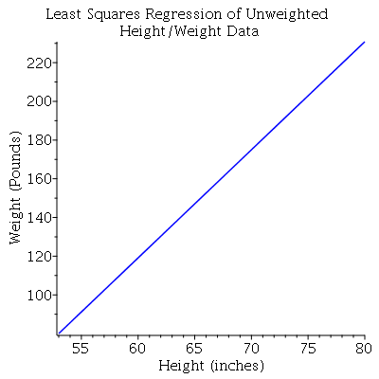

We can use the data to make predictions about the expected weight of a person based on their height. For example, an estimate of the expected weight of a person who is 5’10” (70”), can be calculated as follows:

y = -$\frac{7200118}{33341}+ \frac{186201}{33341}$(70) = 174.98

While this line will approximate the data as given, we must consider bias as a result of certain sampling types. If we assume that people are prone to randomly underestimate their weight by 2-4%, we can calculate a regression line equation that considers this underestimate. If the amount of underestimation is truly random, the expected average value of underestimation is around 3%. We can calculate a weight matrix as the identity matrix multiplied by .97. We then apply that weight matrix to the original equation and proceed as before calculating a new matrix ß which we will call ß* (for differentiation purposes). Our new equation becomes WXß*=y.

W=$\left[\begin{matrix}. 97 & 0 \\ 0 & .97\end{matrix}\right]$

WX=$\left[\begin{matrix}.97 & 74.69 \\ .97 & 69.84 \\ .97 & 62.08 \\ .97 & 70.81 \\ .97 & 66.93 \\ .97 & 62.08 \\ .97 & 69.84 \\ .97 & 64.99 \\ .97 & 63.05 \\ .97 & 70.81 \\ .97 & 71.78 \\ .97 & 70.81 \\ .97 & 72.75 \\ .97 & 64.02 \\ .97 & 71.78 \\ .97 & 77.60 \\ .97 & 61.11 \\ .97 & 65.96 \\ .97 & 51.41 \\ .97 & 61.11 \\ .97 & 68.87 \\ .97 & 60.14 \\ .97 & 74.69 \\ .97 & 61.11 \\ .97 & 70.81 \\ .97 & 70.81 \\ .97 & 69.84 \\ .97 & 64.99 \\ .97 & 71.78 \\ .97 & 67.90 \\ .97 & 67.90 \\ .97 & 68.87 \\ .97 & 71.78 \\ .97 & 66.93\end{matrix}\right]$

$({WX)}^{T}WX$ = $\left[\begin{matrix}31.99 & 2230.87 \\ 2230.87 & 156100\end{matrix}\right]$
$({WX)}^{T}Y$ = $\left[\begin{matrix}5722.03 \\ 404100\end{matrix}\right]$

${(({WX)}^{T}WX)}^{-1}$ = $\left[\begin{matrix}5.30 & -.08 \\ -.08 & 0\end{matrix}\right]$

ß* = $\left[\begin{matrix}ß_{0}^{*} \\ ß_{1}^{*}\end{matrix}\right]$= $\left[\begin{matrix}5.30 & -.08 \\ -.08 & 0\end{matrix}\right]\left[\begin{matrix}5722.03 \\ 404100\end{matrix}\right]$ = $\left[\begin{matrix}-222.63 \\ 5.76\end{matrix}\right]$
The result is the following equation for the least squares regression line using the weighted approach.

y = -$222.63+ 5.76$x

NOTE: I WILL PUT A PLOT HERE SIMILAR TO THE ONE SEEN ABOVE FOR THE PREVIOUS MODEL. I WANT TO DO ALL MY PLOTS IN MAPLE SO THEY MATCH. FINAL DRAFT WILL INCLUDE THIS.

Since we are assuming each person in the data set actually weighs more than the data set states by an average of 3%, we would expect that when we calculate the expected weight for a person of any height, it would be approximately 3% greater than the weight calculated using the previous model. We can check this by calculating the expected weight of a person who is 5’10” (70”) and comparing it to the expected weight calculated using the previous model.

y = -$222.63+ 5.76$(70) = 180.57

$\frac{180.57}{174.98}$ ~ 1.03

The intuition was correct. Below is a visual representation of the original data points and the two calculated least squares lines representing model 1 and model 2.

NOTE: I WILL PUT A PLOT THAT IS THE TWO LINEAR EQUATIONS GRAPHED ON TOP OF THE SCATTERPLOT IN THIS SECTION, I JUST WANT TO DO IT IN MAPLE SO IT MATCHES THE OTHER PLOTS IN THE BODY OF THE PROJECT. FINAL DRAFT WILL INCLUDE IT.
Calculating models as such is relevant in statistical analysis or other fields. Some applications of this model in particular would be in the medical field. As health professionals are continually trying to get an accurate picture of our nation’s health as a whole, they must analyze data from samples of American citizens. Accounting for bias using weighted least squares methods can help them to get the most accurate prediction of the measurements of people in the country. In addition, creating weighted regression lines can help professionals like doctors compare their patients’ real weight to their expected weight in order to make decisions about their health and well-being. In conclusion, utilizing the power of the weighted least squares approach with linear algebra can help to produce more accurate statistical information that allows for those who are performing analysis of data to make more informed inferences.

SOURCES
Linear Algebra and Its Applications, David C. Lay, Stephen R. Lay, Judi J. McDonald
http://uspas.fnal.gov/materials/05UCB/4_LSQ.pdf

