Dave Winkler
Math 5270
Lesson Plan Assignment

Introduction for this assignment
For this lesson plan assignment, I was thinking of what material that we covered in class that I teach. This coming year I will be teaching Secondary I and Secondary I Honors. A few of topics that we covered in class that show up in the common core that I will be teaching deal with vectors, matrices, and basic transformations. The vectors and matrices are only taught in the honor sections of Secondary I. Teaching the matrices and transformations in the classes I taught went okay, but I felt like I needed to develop myself in the realm of vectors and its application. The application of velocity was not discussed in this class but is something in the common core. While teaching Secondary I Honors, I would run out of time for vectors and wasn’t as comfortable with them compared to other mathematical topics. I have taught some very basic information about vectors as an instructor of a part time job I had. This Transformational Geometry class has helped build my mathematical background on vectors and I have decided to use this opportunity of developing a lesson plan to help me build resources that I can use in the classroom when we get to vectors as well as help me understand them better. I had none of these before I started this project and chose this topic so I could learn something and acquire resources. This lesson plan below is set up as one lesson for one class, but in reality would probably be more like a unit of several lesson over the course of maybe a week.
Age Group
This lesson plan is intended for Secondary I Honor students, probably in 8th or 9th grade. These students have not learned any trigonometry as that is done in Secondary II.

Actual Lesson Plan
Objectives
For our objectives, we have content and language objectives. The content describes the mathematics that the students will be striving to learn. The language objective will describe the reading, writing, listening, and speaking that student participate in order to meet the content objective.
Content Objective
Students will be able to compute the magnitude of vectors, add and subtract vectors, find the magnitude of the sum of vectors, find the magnitude of a scaled vector, multiply a scalar by a vector, plot a vector, plot the opposite vector, find the x and y coordinates of a vector, and work with vector velocity problems.
Language Objective
Students will talk with each about vector problems, listen to each other about vector problems, write out vector problems, and listen to vector problems.
Common Core State Standards Alignment
The following was copied and pasted from the website 1, and the font and size was changed to match this word document. The bold was added as it appears on the site, as when it was copied it did not show the bolds. These are the Common Core Standards under the “Vector & Matrix Quantities” under the “High School: Number and Quantity” section of the site and deal with vectors.

Represent and model with vector quantities.
CCSS.Math.Content.HSN.VM.A.1
(+) Recognize vector quantities as having both magnitude and direction. Represent vector quantities by directed line segments, and use appropriate symbols for vectors and their magnitudes (e.g., v, |v|, ||v||, v).
CCSS.Math.Content.HSN.VM.A.2
(+) Find the components of a vector by subtracting the coordinates of an initial point from the coordinates of a terminal point.
CCSS.Math.Content.HSN.VM.A.3
(+) Solve problems involving velocity and other quantities that can be represented by vectors.

Perform operations on vectors.
CCSS.Math.Content.HSN.VM.B.4
(+) Add and subtract vectors.
CCSS.Math.Content.HSN.VM.B.4.a
Add vectors end-to-end, component-wise, and by the parallelogram rule. Understand that the magnitude of a sum of two vectors is typically not the sum of the magnitudes.
CCSS.Math.Content.HSN.VM.B.4.b
Given two vectors in magnitude and direction form, determine the magnitude and direction of their sum.
CCSS.Math.Content.HSN.VM.B.4.c
Understand vector subtraction v - w as v + (-w), where -w is the additive inverse of w, with the same magnitude as w and pointing in the opposite direction. Represent vector subtraction graphically by connecting the tips in the appropriate order, and perform vector subtraction component-wise.
CCSS.Math.Content.HSN.VM.B.5
(+) Multiply a vector by a scalar.
CCSS.Math.Content.HSN.VM.B.5.a
Represent scalar multiplication graphically by scaling vectors and possibly reversing their direction; perform scalar multiplication component-wise, e.g., as c(v_{x}, v_{y}) = (cv_{x}, cv_{y}).
CCSS.Math.Content.HSN.VM.B.5.b
Compute the magnitude of a scalar multiple cv using ||cv|| = |c|v. Compute the direction of cv knowing that when |c|v ≠ 0, the direction of cv is either along v (for c > 0) or against v (for c < 0).

Materials
For this lesson, a computer with overhead projection is needed to show the PowerPoint slides and websites. For most of last year, I had a lab top that could be folded to use one side like a tablet with a stylus that I could write on and the students could see. This lap top was connected to a large flat screen TV where students could see.
Each student would need a copy of a printout of the handout (2).
Also needed are copies of printouts of the two worksheets (3) to give to students as homework of selected problems.
Activities
Students begin by participating in the PowerPoint Slide Presentation. The first thing students learn is about the magnitude and direction of vectors. Then students are asked to plot a vector given the x and y coordinates and then the class goes over this. Students see that the magnitude of the vector is just the distance using the Pythagorean Theorem. Then students are asked to find the magnitude of a given vector and then the class can go over it. Then students learn about how to find the vector’s x and y components when given the beginning and end point of the vector. Then students are asked to do that, and then the class goes over that. Then students learn how to add vectors and practice on that, then the class goes over what students tried. Then students work on subtracting vectors after seeing how it works, and the class goes over what the students worked on. Here students see that subtracting vectors is the same as adding the opposite of a vector. Students then practice adding and subtracting vectors on the IXL website (5). Then students plot the opposite of a given vector and see if they are right as the answer is shown to the class. Next, students work on finding the magnitude and direction of the sum of vectors. Next students see and work on scalar multiplication of vectors and learn if they did it right as it is to be gone over in class. This includes the multiplication as well as the graphing part of this idea. Students then learn about how to calculate the magnitude of a scaled vector. Then students see a video clip (4) that helps strengthen some of the concepts that students have been working on. Then comes the application of vectors, at least on, that deals with vector velocity. Students are given a handout with word problems (2) and the class goes over some of the problems. Then students can work on some of the others as directed as homework. Class time can be given for students to work on these in groups. As students work on the above problems in this lesson, students can be asked to work on some individually, some with a partner, and some with a small group. Lastly, students are given the two worksheets (3) and asked to complete the assignment for homework.
Here are copied images of the PowerPoint Slides
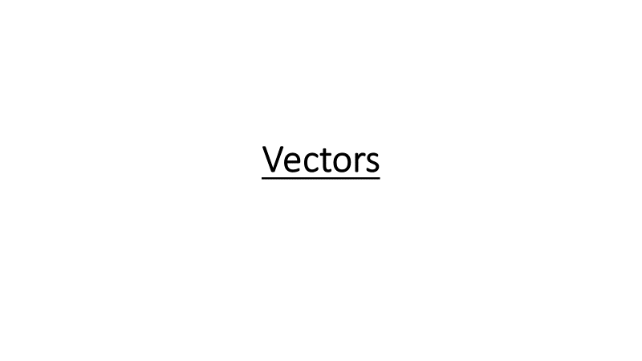
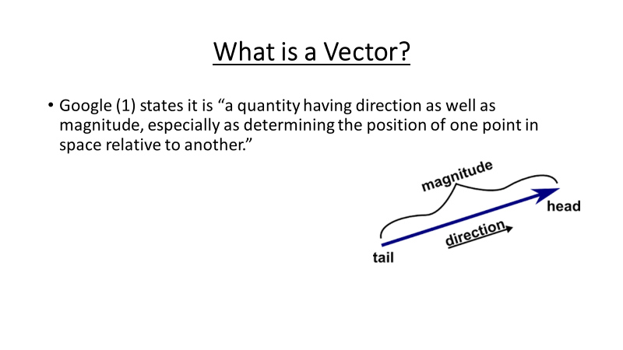
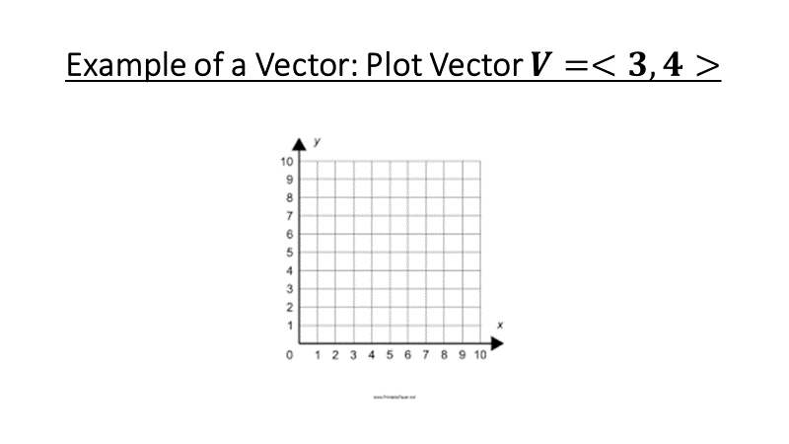
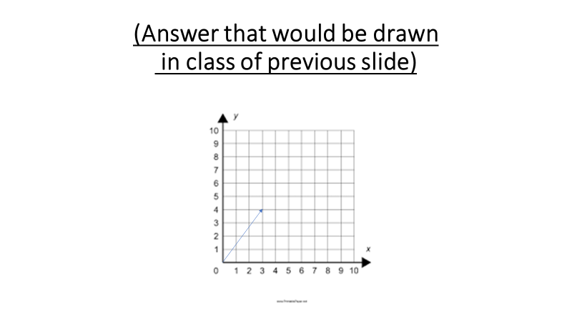
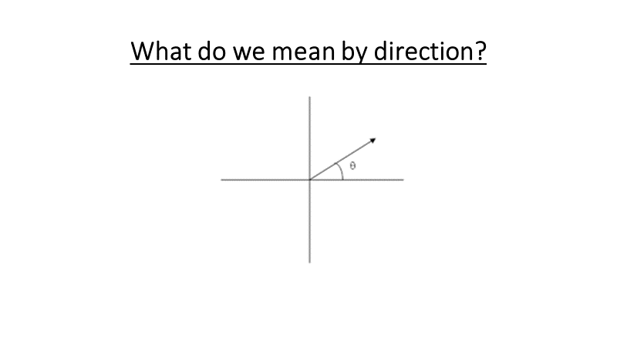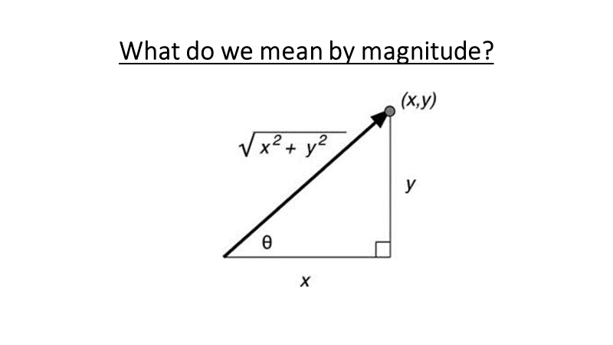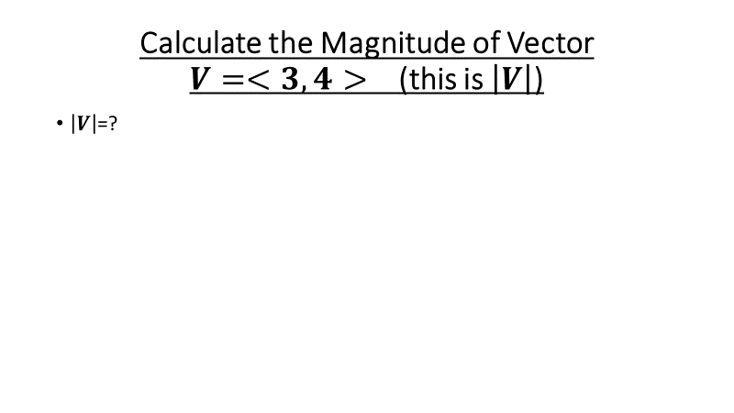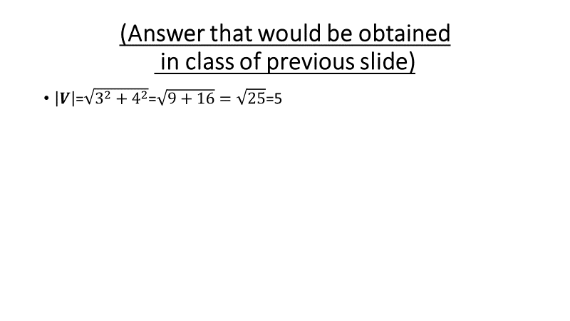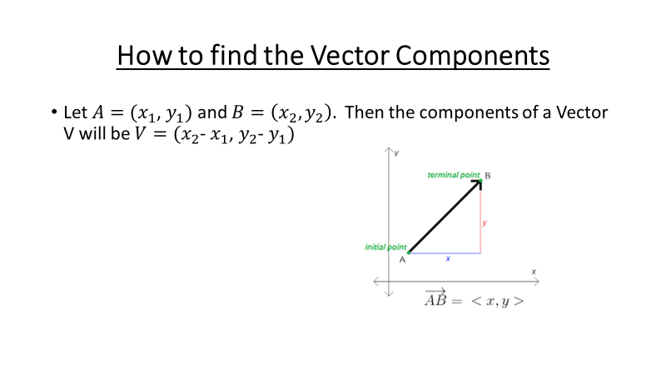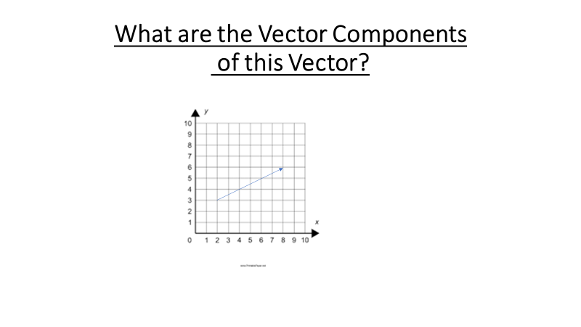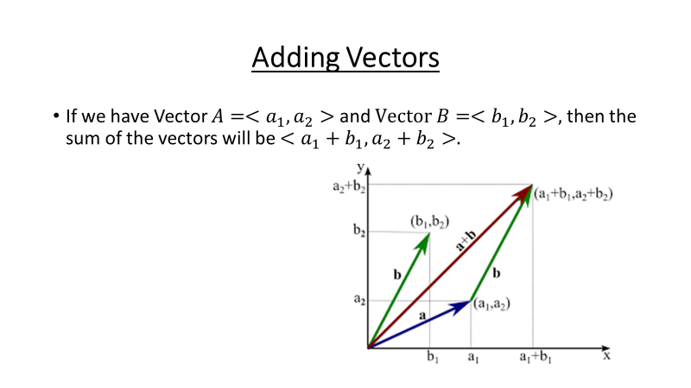
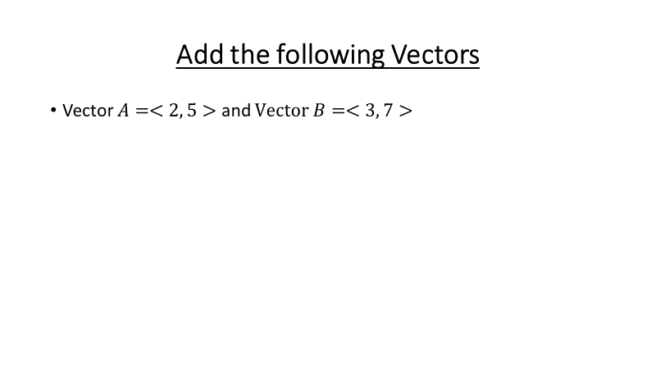
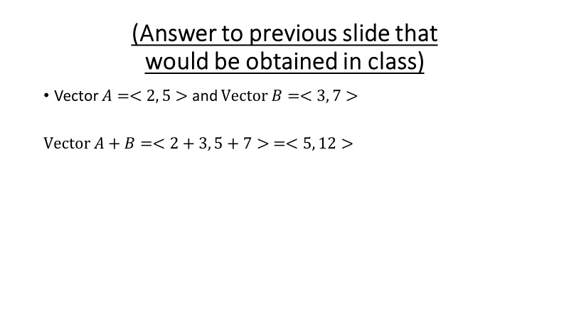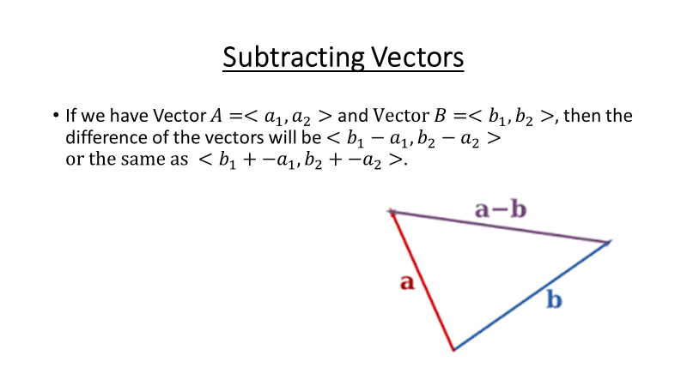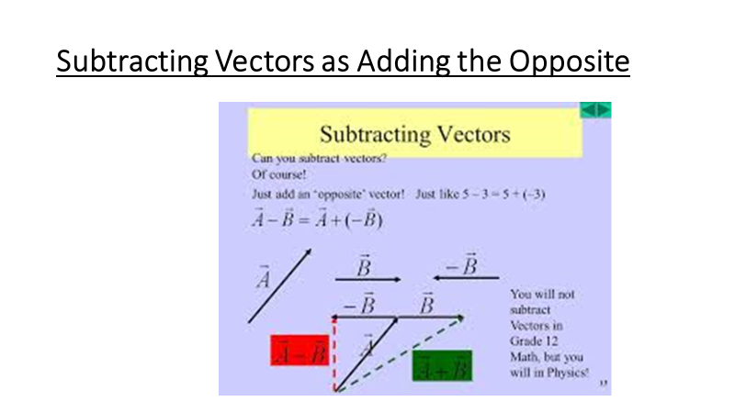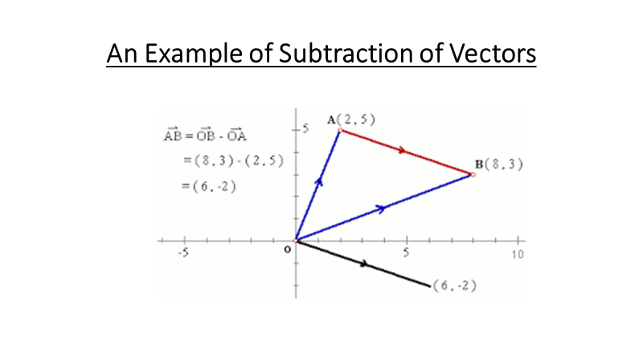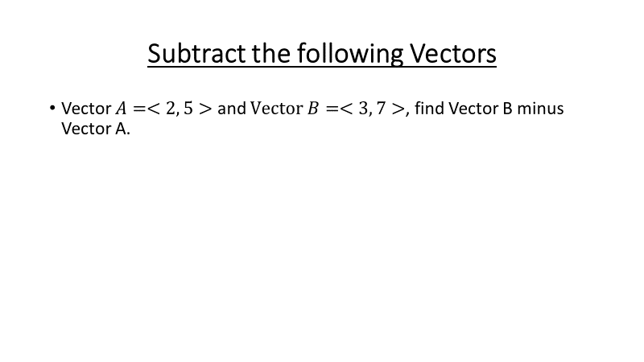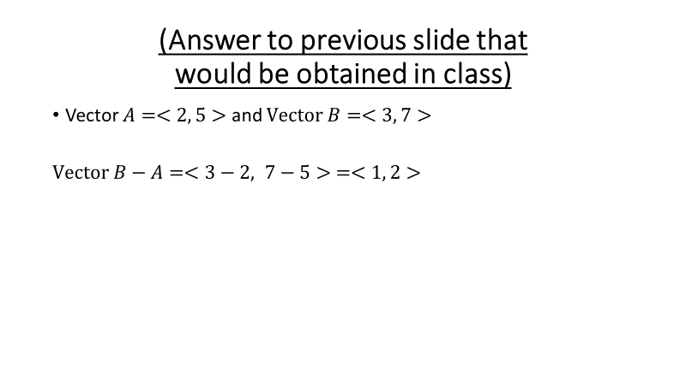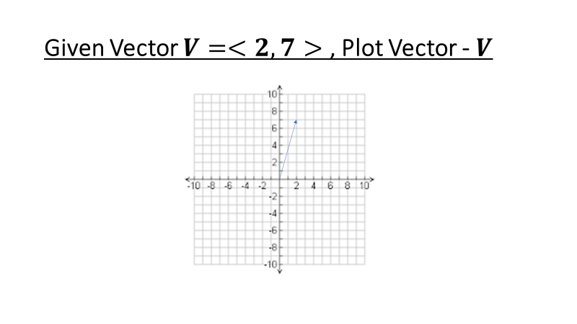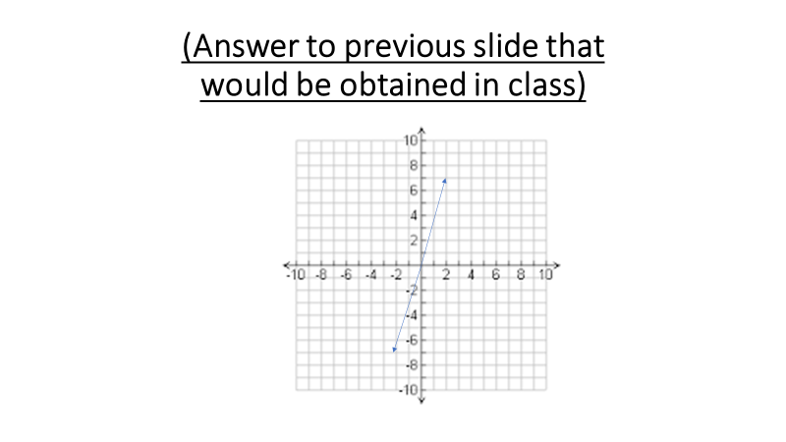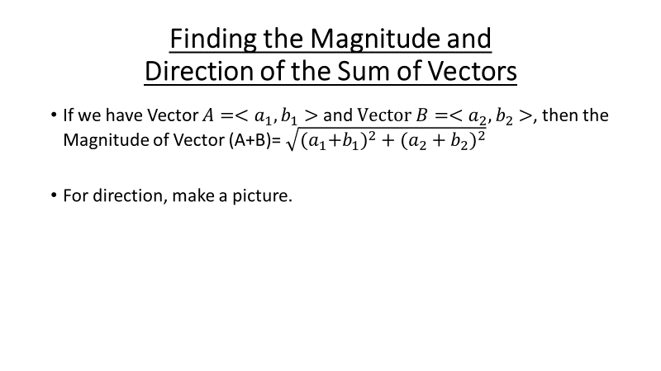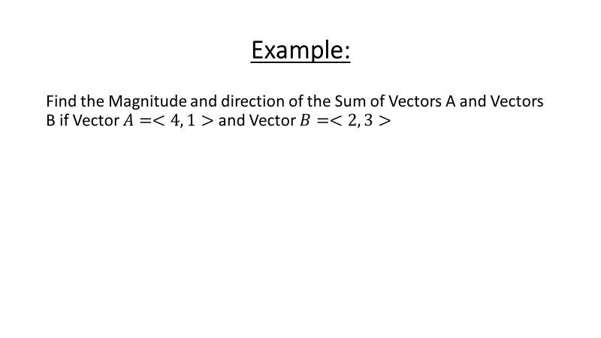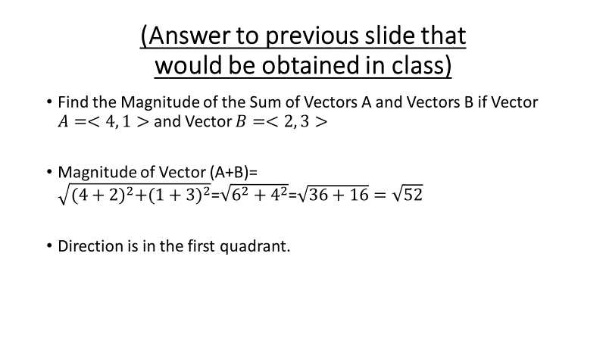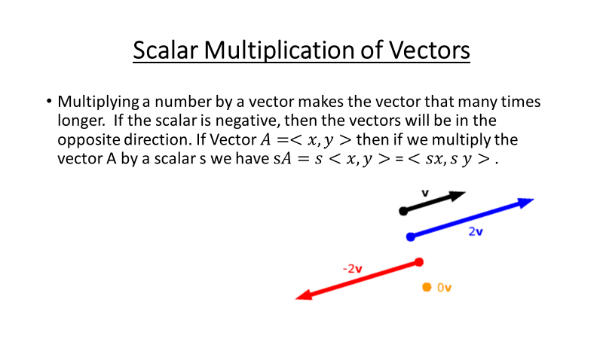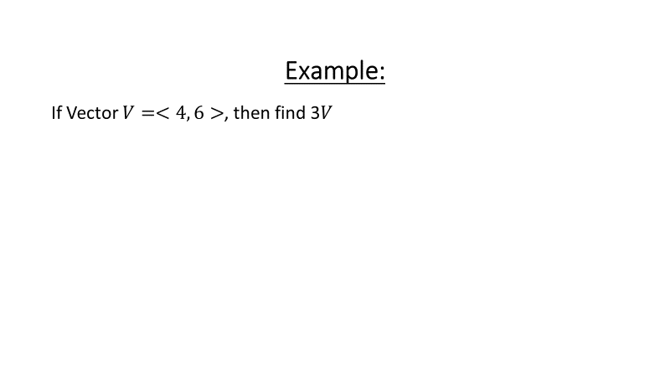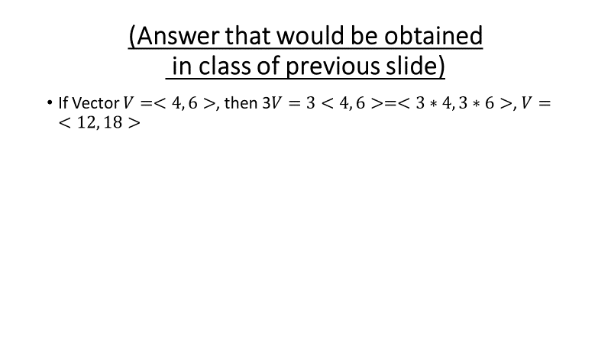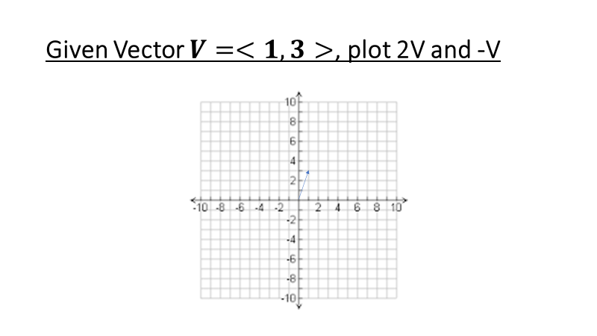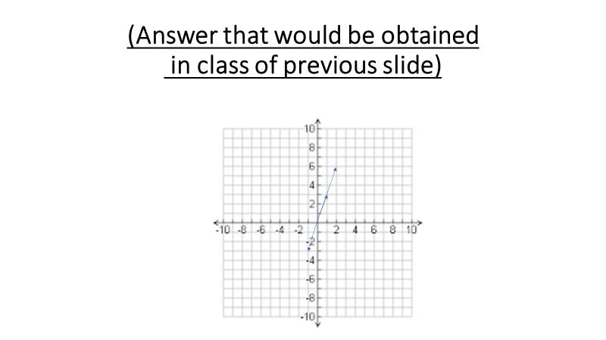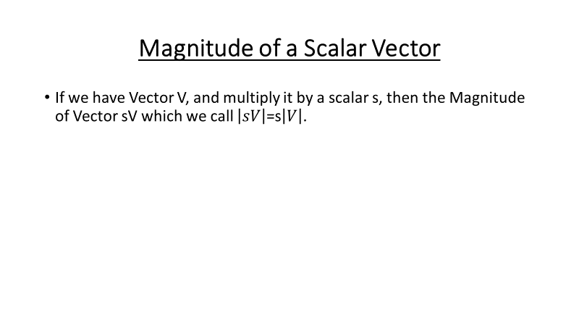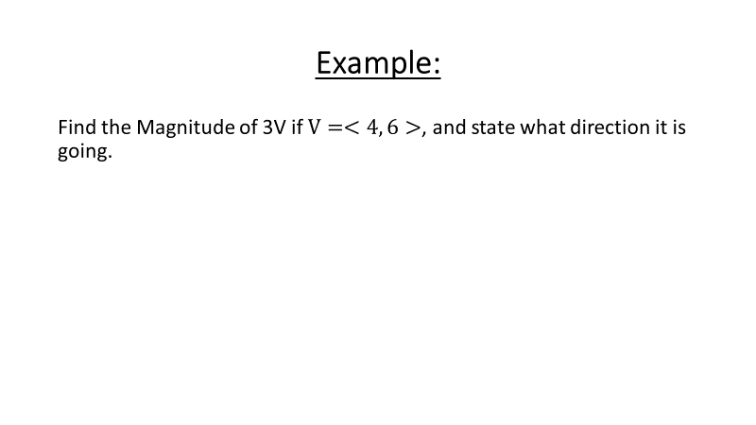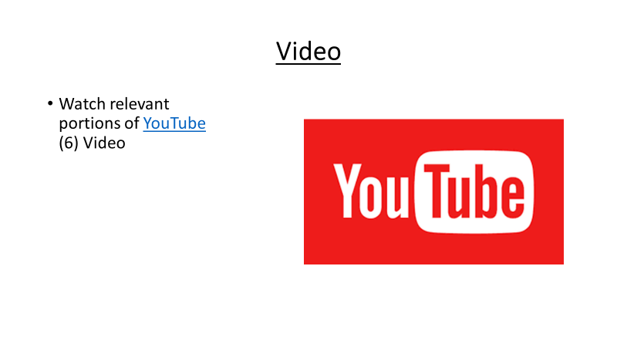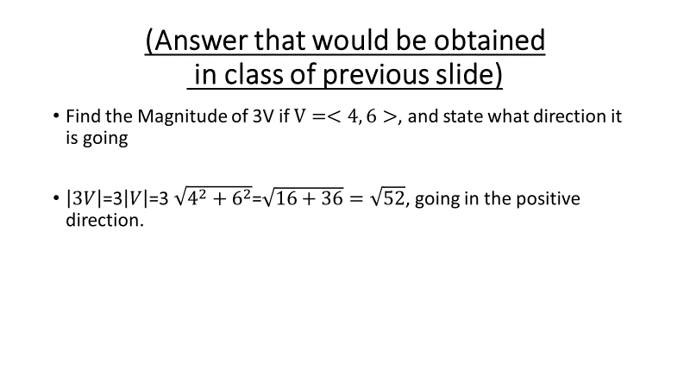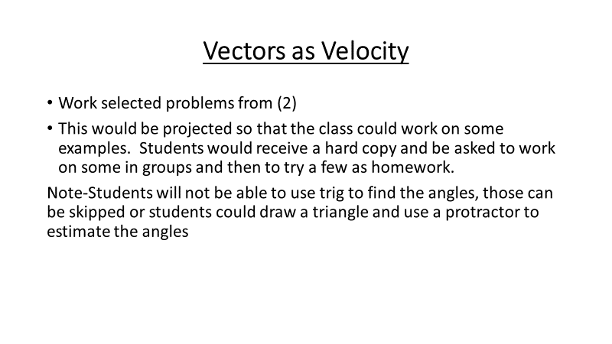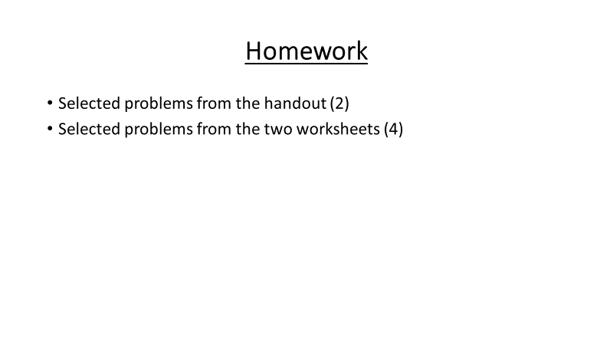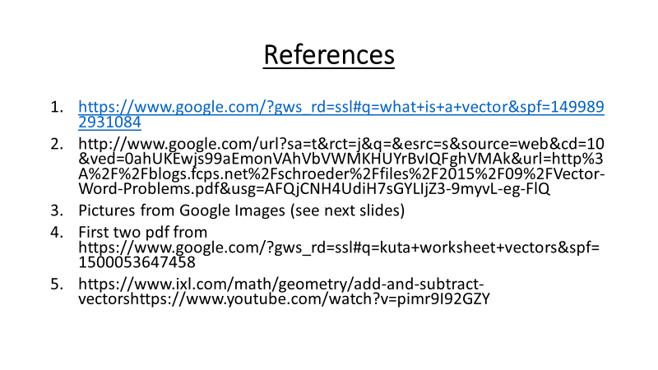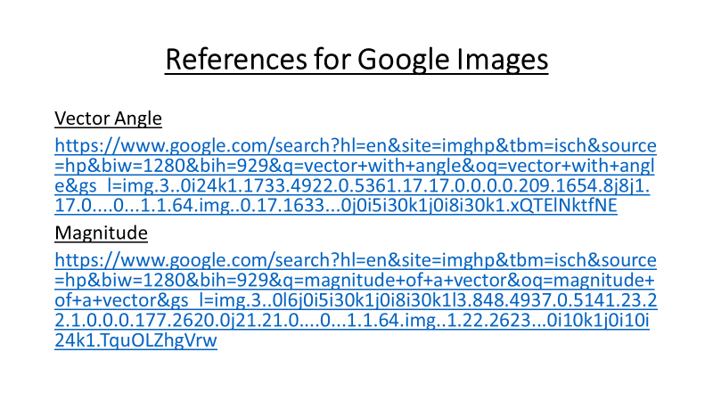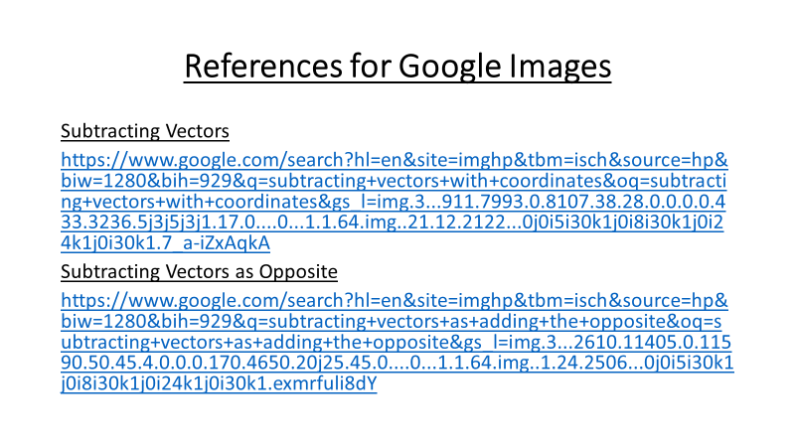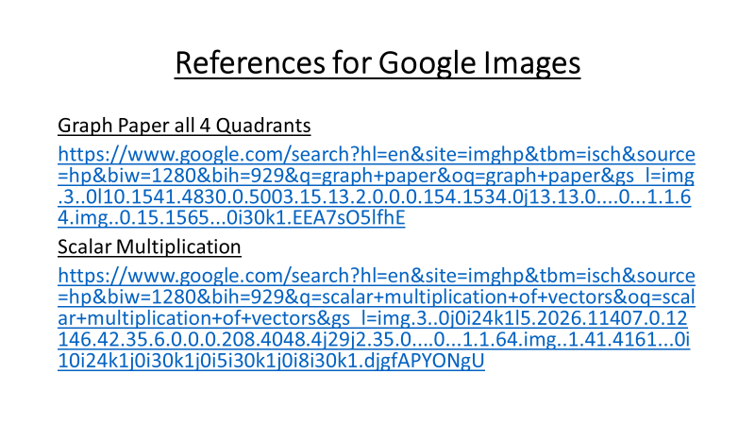

Assessment
Students would work on assignment mentioned in the material section above.
References
- http://www.corestandards.org/Math/Content/HSN/VM/
- http://www.google.com/url?sa=t&rct=j&q=&esrc=s&source=web&cd=10&ved=0ahUKEwjs99aEmonVAhVbVWMKHUYrBvIQFghVMAk&url=http%3A%2F%2Fblogs.fcps.net%2Fschroeder%2Ffiles%2F2015%2F09%2FVector-Word-Problems.pdf&usg=AFQjCNH4UdiH7sGYLIjZ3-9myvL-eg-FlQ
- https://www.google.com/?gws_rd=ssl#q=kuta+worksheet+vectors&spf=1500053647458
- https://www.youtube.com/watch?v=pimr9I92GZY
- https://www.ixl.com/math/geometry/add-and-subtract-vectorshttps://www.youtube.com/watch?v=pimr9I92GZY

